GEORGIA

MINISTRY OF ENVIRONMENTAL PROTECTION AND AGRICULTURE
OF GEORGIA (MEPA)
PROJECT IMPLAMENTATION UNIT

IRRIGATION AND LAND MARKET DEVELOPMENT PROJECT (ILMDP)-P133828
PREPARATION OF DETAILED ENGINEERING DESIGN FOR REHABILITATION AND RECONSTRUCTION OF THE EXISTING SECONDARY AND TERTIARY NETWORKS IN IRRIGATION SYSTEM OF
KVEMO SAMGORI
VOLUME - 3
DRAFT ABBRIVIATED RESETTLEMENT ACTION PLAN (ARAP) FOR KVEMO SAMGORI IN DELIVERABLE-6
On
Contract No: IDIC/CS/QCBS/02-1

Prepared by ILMDP July 2020

Table of Contents
1. INTRODUCTION 8
Project Background 8
Project Approach 9
Project Description 9
Figure 1: Project Layout 11
Efforts to Minimize Land Acquisition and Resettlement Impacts 12
2. Census and Demography 12
Kvemo - Samgori Baseline Census and Socio –Economic Survey 12
Project Affected Area/Population 12
Legal Status of the PAP’s 12
Demographical Survey 13
Census and PAP Category 13
Community and Family Land 13
Socio-Economic Condition of the Livelihoods Income and Employment 13
Education 13
Land Use and Tenure 14
Houses and Land 14
Water Supply and Irrigation 14
Electricity Supply and Gasification 14
3. Review of Legal Framework 14
Overview 14
Georgia’s Laws and Regulations on Land Acquisition and Resettlement 14
Table 1: Legislation of Georgian Pertaining to Land Acquisition and Expropriation 15
World Bank OP 4.12 Involuntary Resettlement Policy 16
4. Project Impact and Valuation 17
Impact on Land 17
Servitude Agreements 17
Impact on Crops 18
Table 2: Crops 19
Impact on Trees 19
Table 3: Perennials 20
Table 4: Cypress Trees 20
Land Restoration 21
Allowance 21
Unforeseen Resettlement Impact 21
ARAP Needs and Strategy 21
Impact on Employment and Agricultural Tenants 22
Impact on Business Income Losses 22
Impact on Common Property Resources 22
Vulnerable Households 22
Gender and Resettlement Impacts 22
Summary of Impacts 23
Table 5: Summary of project impact on land 23
5. Description of Compensation 23
Compensation Eligibility 23
Compensation Entitlement Matrix 23
Table 6: Entitlement Matrix 24
6. Consultations with Project Affected People 1
Population Awareness, Consultations and Communication Strategy 1
7. Institutional Responsibility 1
7.1 Overview 1
7.2 Local Authority 2
7.3 PIU Responsibility 2
7.4 ARAP Team 2
Other Organizations and Agencies 3
7.1.1 Civil Works Contractor 3
7.1.2 Design Consultants 3
7.1.3 Social Safeguards Consultant 3
7.1.4 Auditor Consultant 3
7.1.5 The Court of Georgia 3
7.1.6 Ministry of Finance 3
7.1.7 World Bank (WB) 3
Chart 1: ARAP Organization Chart 4
8. Grievance Redress Mechanism for Abbreviated Resettlement Action Plan 4
Introduction 4
8.2 Project Grievance Redress Principles 4
8.3 Grievance Resolution Process 5
Table 7: Resettlement Grievance Resolution Process 5
8.4 Grievance Resolution Process 5
8.5 Grievance Recording and Logging 5
8.6 PIU Grievance Contact Information 5
9. Arrangement for Monitoring and Project Implementation 6
Monitoring 6
Monitoring and Evaluation Indicators 7
Post-Implementation Evaluation 7
10. Timetable and Budget 8
ARAP Implementation Schedule 8
Table 8: Implementation trimline 8
Budget 8
Itemized Budgets 8
Summary of the ARAP Cost 9
Table 9: Summary Estimate of ARAP Costs 9
Annex 1: Photos of the Public Meetings 10
ANNEX 2: GRM Brochure 18
Annex #3 – Valuator Report 22

Abbreviations

ARAP Abbreviated Resettlement Action Plan
PAP Project Affected Person
BP Bank Procedure
EA Executing Agency
EIA Environmental Impact Assessment
ESMP Environmental and Social Management Plan
GA Georgian Amelioration
GC Grievance Commission
ILMDP Irrigation and Land Market development Project
GEF Global Environmental Fund
GEL Georgian Lari
IFI International Financial Institutions
MEPA Ministry of Environment Protection and Agriculture of Georgia
NAPR National Agency for Public Registration
OP Operational Policy
OM Operational Manual
PIU Project Implementation Unit
PAP’s Project Affected Persons
RAP Resettlement Action Plan
ROW Right of Way
SSC Social Safeguard Consultant
RPF Resettlement Policy Framework
USD United States Dollars
WUO Water User Organization
WB World Bank

Glossary
Beneficiary Community: All persons and households situated within the government-owned or private property that benefits from project investments, and who voluntarily or not voluntarily are affected by the Project.
Compensation: Provision of cash or in-kind compensation for losses incurred by project-affected persons.
Cut-off date: The start date of the census of affected persons, lands, assets and all related resettlement impacts is announced as a cut-off date for the Project. Assets which appear at the project site after
the cut-off date will not be eligible for compensation.
Entitlement: Range of measures comprising compensation, income restoration, transfer assistance, income substitution, and relocation, which are due to affected people, depending on the nature of their losses, to restore their economic and social base.
Improvements: Land constructed (dwelling unit, fence, waiting sheds, animal pens, utilities, community facilities, stores, warehouses, etc.) and crops/plants planted by the person, household, institution, or organization.
Land Acquisition: The process whereby a person is compelled by a government agency to alienate all or part of the land a person owns or possesses to the ownership and possession of a government agency for public purpose in return for a consideration.
Economic Displacement: Economic displacement means loss of land, assets, access to assets, income sources, or means of livelihoods as a result of (i) involuntary acquisition of land, or (ii) involuntary restrictions on land use or on access to legally designated parks and protected areas.
Project Affected People -PAP’s: Individuals affected by Project-related impacts – losing the usage capacity on land, water, natural resources or income.
Project Affected Household (PAH): All members of a household residing under one roof and operating as a single economic unit, who are adversely affected by the Project. It may consist of a single nuclear family or an extended family group.
Rehabilitation: Compensatory measures provided under the Resettlement Policy Framework on involuntary resettlement other than payment for the improvements to be made on affected land plots such as soil leveling improvements, cleaning from debris etc.
Relocation: The physical relocation of a PAPs/PAHs from their pre-Project place of residence.
Replacement Cost: The value determined to be fair compensation for land based on the cost of buying a similar piece of land – one with similar productive potential and location. The replacement cost of houses and land is current fair market price of building materials and labor without depreciation or deductions for salvaged building material.
Resettlement: All measures taken to mitigate any and all adverse impacts of the Project on AP’s property and/or livelihood, including compensation, relocation (where relevant), and rehabilitation of the damaged/removed infrastructure and installations.
Servitude Agreements - partial impacts: land use restrictions to project affected arable land parcels that will limit the potential best use of these land parcels. PAP’s will maintain ownership/possession rights to project affected land parcels and still be allowed to cultivate for agricultural purposes and will be compensated for the restrictions imposed by servitude.
Vulnerable groups: Groups or individuals who may be either disproportionately and adversely affected by the project or face barriers to fully partake in the benefits provided by the project. These groups will be defined in RAP and provided with additional compensation and/or assistance.

INTRODUCTION

Project Background
The World Bank finances the Irrigation and Land Market Development Project (ILMDP) (US$70 million). The project development objective is to improve delivery of irrigation and drainage services in selected areas and to develop improved policies and procedures as a basis for a national program of land registration.

The project consists of the three components: Component 1) Irrigation and Drainage Improvement (US$54.65 million) Component 2) Land Market Development (US$12.35 million) and 3) Project Management (US$3.0 million). Component 1 is implemented by the Ministry of Agriculture through the Project Implementation Unit (PIU). Component 2 is implemented by the Ministry of Justice through the National Agency for Public Registry.

The Irrigation and Drainage Rehabilitation and Modernization Subcomponent will finance rehabilitation and modernization of existing irrigation and drainage schemes selected under the project. Namely, the project will finance rehabilitation of primary, secondary (off-farm), and tertiary (on-farm) canals. Other works, such as head-works, work on dams and on other lands in project area are not envisaged. The project will only restore existing irrigation canals and does not envisage construction of new schemes. For the first stage of the project, three irrigation schemes have been selected for rehabilitation. Those are - Kvemo Samgori, Tbisi-Kumisi and Zeda Ru irrigation schemes.

The PIU is in charge of the rehabilitation/re-construction of secondary and tertiary irrigation networks. Due to the nature of rehabilitation and re-construction works and using existing routes only, the environmental and social risks of PIU Project are assessed as moderate. Civil works are not expected to influence territories outside of the project sites, nor to cause significant or irreversible impacts. Still, the reconstruction works are expected to cause some impacts on private assets such as on trees, crops, fences, and auxiliary structures located or in close proximity to the canals which will be rehabilitated. Additionally, project works may entail servitude agreements, which would impose some restrictions on the use of land by their owners.

The purpose of the current assignment is to develop a resettlement action plan to ensure that any expected losses incurred by project affected persons in the course of project works on the 247 km long Kvemo Samgori secondary and tertiary canals will be compensated in accordance with World Bank (WB) requirements, and in particular, the WB Operational Policy (OP 4.12) on involuntary resettlement.

According to the WB OP 4.12, Paragraph 25: “Where impacts on the entire displaced population are minor, or fewer than 200 people are displaced, an abbreviated resettlement plan may be agreed with the borrower”. Since the affected people on the Kvemo Samgori scheme are less than 200 people, an Abbreviated Resettlement Action Plan (ARAP) is prepared.

In October-November 2019, the project team conducted initial screening and census of the project area in Sagarejo Municipality of the Kvemo – Samgori area of Georgia. Approximately 31 agricultural land plots were identified as potentially affected by the rehabilitation of the Kvemo Samgori secondary and tertiary irrigation canal project. Rehabilitation works will mostly affect those land plots where pipeline will be put and buried underground.

Project Approach
This ARAP sets out the measures to be taken in order to mitigate impacts on Project Affected Persons, providing them with adequate compensation, and where necessary, with due assistance for restoring their livelihoods. The RAP is being prepared in consultation with project-affected persons and is subject to further public consultation prior to being implemented.
The Abbreviated Resettlement Action Plan is aligned with the requirements of the WB OP 4.12 and complies with national legislative requirements of Georgia.

To develop the present Abbreviated Resettlement Action Plan, information on final design of civil works provided by Project Implementation Unit and design company Su-Yapı Engineering & Consulting and Geo Consulting Group. Based on the field trips conducted in 2019 SSC, PIU and design company representatives developed a detailed inventory of infrastructure and a preliminary assessment of rehabilitation needs along the entire Kvemo - Samgori 247 km irrigation canal.

The project territory is located in Sagarejo Municipality and goes through the lands of the Ninotsminda, Giorgitsminda, Guzagrama, Iormughalo, Shibliani, Tulari, Lambalo and Khandaura villages. According to the drawings provided by the PIU and Su-Yapi, no permanent impact is expected on the project territory. The estimated impact is temporary and expected only during rehabilitation period. After rehabilitation is completed the area will be levelled, and fully restored to pre-project condition, and owners can continue agricultural activities. Where rehabilitation occurs within residential areas, the area will be similarly restored, and improved where necessary, to ensure full and safe access by residents.

As noted above, 31 land plots were identified as potentially affected by the project the land plots are privately owned. Six land plots are under agricultural activities and owned by registered legal companies. Two companies are registered by women. In total there are 5 women owners affected by project.

The present Abbreviated Resettlement Action Plan, prepared in accordance of the World Bank OP 4.12 and the national legislation of Georgia, sets the principles and procedures that will govern resettlement activities. It identifies the categories of affected persons and their respective entitlements, and describes the actions that need to be taken, during and after implementation of the current Abbreviated RAP.

Project Description
Currently, the secondary and tertiary canals run on both sides of the main Kvemo - Samgori irrigation canal. The Canal is located in Sagarejo Municipality and goes through the lands of the Ninotsminda, Giorgitsminda, Guzagrama, Iormughalo, Shibliani, Tulari, Lambalo and Khandaura villages. The rehabilitation of the main canal was completed in 2016-2018.

During the Soviet era, the area was known for its agricultural activities. Mainly there were “Kolkhoz” unions (cooperatives) and the area was known for growing grapes for winemaking. The wine was sold in other Soviet republics. After breakup of the Soviet Union the territory deteriorated, the wineries disappeared, the irrigation system was dismantled, and no agricultural activities were conducted in the area. After the breakup of the Soviet Union one of the main reasons not having massive agricultural activities in the area was lack of the sustainable water supply to the land plots. Having these problems GoG decided to rehabilitate the main Kvemo-Samgori Irrigation Scheme, and at the second stage, rehabilitate remote and secondary canals that have access to the secondary land plots. This is one of the reasons for rehabilitating the Kvemo-Samgori Irrigation Scheme in order to make remote lands accessible for irrigation and increase agricultural productivity of the area.

The Project Implementation Unit in coordination with design company Su-Yapı Engineering & Consulting and Geo Consulting Group developed design documentation that covers secondary and tertiary canal rehabilitation of the entire Kevmo- Samgori Scheme. According to the design documentation the entire length of the pipeline will be about 247 km. The pipeline is of 100-600 mm dimeter and is laid into the ground. The pipeline will have hydrants that will be located on top of the ground and farmers will have access to water from hydrants to their land plots. According to the preliminary survey of the territory and design solutions pipeline will be put into the ground and leveled afterwards.

According to the design documents, no permanent land take is necessary for rehabilitation activities. During construction activities it may be necessary to have temporary access roads or additional passes to the land plots and maintenance facilities (e.g. hydrants, closing barriers etc.) Any impacts associated with access roads, machinery or damages thereof will be compensated by the contractor. The right of way (RoW) of the pipeline is 4 meters width and the pipe will be put into the ground approximately 1-1.5 meters depth. During the operation phase, the Georgian Amelioration Company will need access to operate underground pipe in case of any damage or accident occurs, therefore the servitude agreements will be signed between MEPA and the respective land owners in order to operate pipeline in future. (786” Civil Code of Georgia”, 26/06/199, ref :040.000.000.05.001.000.223)

During the site visit and census conducted in October - November 2019 it was determined that the proposed project area is agricultural arable land. There are only minor to medium agricultural activities ongoing in the area. The new pipeline will run through private land plots. The land plots are mostly agricultural and are used for farming. On some project impacted land plots are used for grazing and for hay. In some areas the land selected for pipe construction runs along existing dirt roads that are not private. These tracks mostly are for farm operation and remain there for the time being.

Figure 1: Project Layout
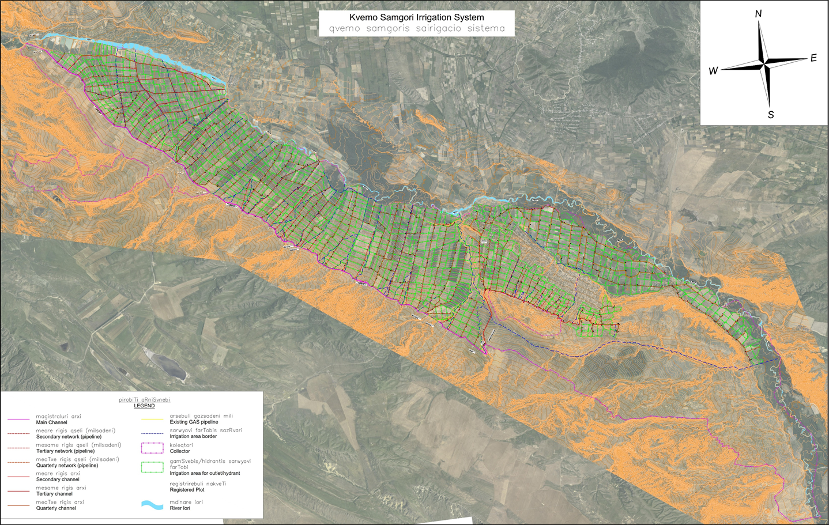

Efforts to Minimize Land Acquisition and Resettlement Impacts
During the site visits in October- November 2019 both design and resettlement team analyzed the route in terms of minimizing land acquisition and resettlement issues. The following considerations were made to avoid and/or minimize land acquisition and involuntary resettlement impacts:
- Refining and rerouting the pipeline in order to avoid farming areas;
- Consultations with land users regarding the pipeline locations and realignment as needed to avoid physical displacement;

Census and Demography

Kvemo - Samgori Baseline Census and Socio –Economic Survey
The purpose of the Survey and Socio –Economic Study is to describe baseline conditions of the potential Project Affected Persons (PAP’s) within the project area. A survey and interviews were used for this purpose. The project team interviewed PAP’s and the representatives of the Sagarejo Municipality. The project team also conducted inventory of the land plots and identified whether the lands are used for agricultural, business, or other activities. As noted above, based on survey 31 land plots and 27 Project Affected Parties were identified and interviewed, their land was visited and an inventory was conducted.

Project Affected Area/Population
The project area is located in the East Georgia Kakheti Region, Sagarejo Municipality, 46 km from Tbilisi. The total length of the project pipeline is about 247 km. The proposed section of the irrigation canal runs through the lands of eight communities: Ninotsminda, Giorgitsminda, Guzagrama, Iormughalo, Shibliani, Tulari, Lambalo and Khandaura.
The project area for Census and Socio–Economic Survey for Kvemo - Samgori Irrigation System covered the population of these eight villages, in particular population residing near the project area and owning the land plots.

Legal Status of the PAP’s
All the lands within the project area are state or private arable registered plots under the land owners. The ownership is registered either on one owner or in some cases there are co-owners of the land. In addition, there are six Limited Liability Companies and Joint Stock Companies registered in the legal registry and these companies are run by their representative Directors. Some of the Directors are foreigners of Iranian origin. PIU representatives met the company representatives and individually explained them about project, signed inventories and showed the drawings of the project. Under current ARAP the land within the project area is mainly is used for hay harvesting.

Four land plots are used by land users (renter/leaseholder) although during discussion with the land owners they do not hold any legal documents with these land holders and land users are harvesting alfalfa or hay on their own with verbal consent with the owner.

Demographical Survey
According to the data from the National Statistics Office of Georgia (Geostat), there are 310 thousand people living in Kakheti, Georgia. Of these 52 thousand live in Sagarejo. Majority of population is Georgian, while ethnic minorities include Azerbaijanis, Armenians, Ossetians and Russians. Within the project area there are mainly Georgians and Azerbaijani living. There are five Azerbaijani PAP’s within the project area.

Census and PAP Category
According to the census conducted within the project area, there are 31 affected land plots owned by a total of 27 persons including co-owners of the land plots, among them: 2 women company owners, 3 women owners or co-owners of the land plots, and 22 men (main owners). In addition to the 27 owners there are also 4 informal tenants on the impacted land plots. The average age of PAP is 35 years and maximum 86 years old.

Community and Family Land
The community within the project area is traditional and comprises close network of family, extended family, neighbors. This has informal influence on the community in total. The cultural attitudes also have influence on economic developments as well. Therefore, any economic development within the area has to be consulted within communities. The financial conditions of the population are similar to other rural areas of the country. The area also has Azeri-speaking ethnic/religious minority population.

Socio-Economic Condition of the Livelihoods Income and Employment
Based on the interviews conducted with community representatives, the majority of the population is involved in agriculture. They are producing products for personal usage and selling some of these products at the markets. Almost all families own cattle and poultry. While the respondents were mostly reluctant to disclose financial information, the surveyors estimate that families have 5-10 heads of cattle on average. The average monthly income per family is 500 to 1000 Lari. Most of the income is generated in Fall, by selling agricultural products.

According to the interviews conducted, the majority of males are employed in agriculture, and some of them have employment in administration as well. Females are mainly involved in agriculture and housekeeping activities. Some have permanent jobs at local schools, administrative work, or work in other service jobs.

Besides the local population, some land in Kvemo- Samgori Irrigation scheme is owned by businesses. These are six enterprises that are owned by private owners. These businesses own lands and have no activities within project impacted area except hay on their land plots. Some of the land owners within the territory are not the representatives of the community and they are from Tbilisi and bought lands ten - tree years ago.

Education
There are elementary and high schools within the Region. There are secondary schools in all villages. Therefore, education is easily accessible for local population. The approximate average number of school children does not exceed 180 to 550 per school. There are nurseries (kindergartens) in almost all villages, with an average of 25-35 children per classroom.

Land Use and Tenure
Since 1991, Georgia has started land reform. In 1992, the GoG approved a resolution on privatization. According to this resolution, every household has the right to obtain 1.25 ha of agricultural land. Later, in 1996, the land was transferred into private ownership. According to the legislation the local population received 1.25 ha of lands and civil servants 0.75 ha. In addition, a part of the population has purchased state lands, others rent from private owners or from the State for agricultural purposes. All the lands within the project area are registered and have owners.

Houses and Land
The majority of the houses were constructed in the 20th century in the period between1960-1990. There is also some new construction and development in the villages in recent years with houses built in the last 10 years. The houses are mostly 2 storied and approximately 100 - 200m² and are made of brick or concrete blocks. The windows and floors are plastic and roofs covered with tin roofs. In addition, there are additional 1 storied structure attached to residential dwellings or separately located on the same private land parcels owned by the households.

Water Supply and Irrigation
Water is not permanently supplied to the project affected villages. Most of the population gets water from wells although not everybody has a well. Some of the villages had centralized water supply networks during the Soviet times. Currently all these systems are depreciated and out of order. Sewage systems do not exist.
The irrigation reservoir constructed on the River Iori supplies water to the Zemo Samgori irrigation canals. Under the existing legislation for the irrigation services population is annually paying 75 GEL per hectare.

Electricity Supply and Gasification
Electricity in the region is supplied by Energo-Pro Georgia, at reliable quality of service. None of the surveyed PAP’s complained about supply disruption.
Currently, the natural gas pipe is also installed in the region, however only 25-31% of the population has gas in the houses via individual meters. Based on the information provided by the population, gasification is very expensive and costs approximately 900-1200 GEL to connect to their houses. Thus, they cannot afford to have gas in the houses.

Review of Legal Framework

Overview
This section provides a summary of the relevant legal framework in Georgia as well as international standards applicable to land acquisition and resettlement processes.

Georgia’s Laws and Regulations on Land Acquisition and Resettlement

Table 1: Legislation of Georgian Pertaining to Land Acquisition and Expropriation

Legal document | Adoption Year | Key Land Issues under Regulation
Constitution of Georgia | 1995 | Frame legislation covering private ownership, privatization, compensation, expropriation and publicity issues.
Civil Code of Georgia | 1997 | Frame legislation covering ownership rights, construction right, servitude rights and necessary right of way issues.
Civil Procedural Code | 1997 | The general courts of Georgia consider the cases (including land ownership expropriation cases) according to the rules identified under the Procedural Civil Code of Georgia.
Law on Defining the Purpose of the Land Use and on Sustainable Management of Agricultural Land [some points of the law will become effective from 1 January 2020 and some from 1 July 2020]. | 2019 | The law establishes the rules and compensation levels (according to municipalities and recreational zones) for allocation of agricultural lands for non-agricultural land use purpose.
Law on Recognition of the Property Ownership Rights Regarding the Land Plots Owned (Used) by Physical Persons or Legal Entities | 2007 | The law determines basic terms and conditions for recognizing property rights of lawfully possessed (used), as well as informally used (squatted) land and the rights of the state in the process of recognition of the property rights.
Law on Procedures for Expropriation of Property for Necessary Public Need | 1999 | The law determines rules of granting the right to expropriation for necessary public purposes and rules of implementing expropriation. It also It contains a list of activities (projects), which may require expropriation for necessary public purposes, including electricity transmission and distribution lines.
Law on the Rule for Expropriation of Ownership for Urgently Necessary Public Needs | 1997 | This law contains very generic provisions expropriation of property under the urgent need and recognizes the need for providing preliminary, full and fair compensations.
Law on Ownership Rights to Agricultural Land [some points of the law will become effective from 1 January 2020] | 2019 | This law regulates ownership rights and entitlements over the agricultural land parcels, as well as the conditions for acquisition.
Law on Public Registry | 2008 | Law determines the organizational and legal basis for maintaining a public registry, and the rights and duties of the Legal Entity under Public Law (LEPL) called the National Agency of Public Registry, a body operating under the Ministry of Justice of Georgia and responsible for maintaining the public registry.
Law of Georgia on State Property | 2010 | The law regulates the relations related to management, disposal and use of state property of Georgia
Law of Georgia on Protection of Cultural Heritage | 2007 | Permits and procedures for the Right-of-way (RoW) approval through Archaeological clearance (within the Construction Permit)
Decree of the Minister of Urbanization and Construction of Georgia #19, 30/06/2003, On Construction Norms of the Amelioration System Right of Way”. | 2003 | This Decree sets out the procedures for the protection of irrigation lines including the parameters (area, distances, width, clearances) of the protective zones, access roads, protection zones /RoWs.
Regulation of the Prime Minister of Georgia #409, 31/12/2013” the Technical Norms of the Operation of the Amelioration Canal”. | 2013 | The regulation sets the norms of canal operation activities and rule for management of the canal by Georgian Amelioration.
Regulation of the Prime Minister of Georgia #440, 31/12/2013” On Water Protection Norms of the Operation of the Amelioration Canal”. | 2013 | The regulation sets water protection norms of the canal and how these zones should be protected.
* As of April 2020.
The legislation of Georgia envisions the right of the State to acquire privately held land plots through negotiated settlement (this option should be preferred, where possible) or the State can expropriate any property in case of necessary public need. A key principle in the legislation is that compensation of physical assets should be provided based on current market value and should be full, fair and paid in advance. The laws also provide for compensation from income losses (such as loss of harvest) to cover net losses. The legislation also recognizes the concepts of Right-of-Way and the Limited Use of Property. Specifically, the Civil Codes introduces the following concepts: servitude, usufruct, and the right to superficies. The laws require consultation with and prior notification of the affected people, so that they are fully aware of and participate in the expropriation process.
Within the framework of the above laws and regulations, MEPA will have a possibility to legally enter into negotiated agreements with the project affected persons (PAPs) and to draft servitude contracts with land owners. In particular, MEPA will enter into servitude agreements through voluntary negotiated settlements prior to the start of any site works. Only if and when efforts to negotiate the mutually acceptable agreement fail, PIU may address the Government of Georgia and or Court of Georgia with the request to assist in obtaining rights to land, through servitude.

World Bank OP 4.12 Involuntary Resettlement Policy
Under the WB OP 4.12 resettlement is considered involuntary when affected individuals or communities do not have the right to refuse land acquisition that result in displacement. Although every effort to avoid involuntary land acquisition is being made, the Project can resort to expropriation or impose legal restrictions on land use if negotiations fail.

The text below provides an analysis of the gaps between Georgian Laws and Lenders’ policies and requirements. The key measures to bridge the gaps, which form the policy of PIU in addressing Project land acquisition and resettlement, are:

- An ARAP is prepared for the project for partial long-term impact on land impact;
- There is consultation with affected persons, socio-economic surveys and consideration of vulnerability;
- Resettlement is avoided wherever possible and adverse impacts will be minimized first and mitigated second;
- The Project compensates people whether or not they are the formal owners, if they have a legitimate claim to land, structures, crops or other assets;
- Options for compensation, such as land-for-land and full or partial cash compensation, are presented to PAP’s wherever this is practical;
- Cash compensation is based on replacement cost;
- The Project establishes a transparent and accessible grievance mechanism for PAP’s to use throughout the land acquisition process;
- The Project aims to use a participatory approach, which entails consultation with key stakeholders and PAP’s regarding resettlement, in order to promote better and timely implementation of key processes such as measurement and valuation;
- Tailored consultation measures will be adopted to ensure that vulnerable PAPs have the opportunity to access information and provide their feedback in the project and resettlement process;
- Resettlement information was communicated to PAP’s during the community and individual meetings;
- RAPs and all related documents will be disclosed on WB and MEPA website.
- Livelihood restoration and resettlement activities will be monitored during Project implementation via internal monitoring and resettlement audits.

Project Impact and Valuation

Impact on Land
This section provides a summary of the magnitude of impact that will be associated with Kvemo -Samgori secondary and tertiary canal rehabilitation and operation activities. It identifies impacts based on losses including land, crops, and trees.

The impacts on land are partial, which means that the land is not taken (purchased) and is left in a possession of the private owner via servitude/easement in the project area, therefore certain limitations are imposed on the land plots in terms of admissible land use. These include prohibition of placing buildings or other structures, and planting trees, on top of the pipeline and within 2-2 meters from central line on each side of it.

Based on the field surveys, design documentation and interviews with population, the rehabilitation activities do not require any permanent land take. Land plots were visually assessed and divided in two legal categories:

Category 1: Private registered arable land plots: 28

Category 2: Residential land plots: 3

The total number of land plots, including arable and residential, is 31. There are 4 land plots which have multiple co-owners.

All these land plots including arable and residential have to be put under the servitude agreement equal to 60,279 sq.m. 28 Arable land plots to be put under the servitude agreement in total equals to 58598 sq.m. Three residential house land plots to be put under the servitude agreements in total equals to 1681 sq.m.

Servitude Agreements
The majority of the project territory is arable land plots. There are only three land plots with residential houses. Land owners mainly use these parcels for farming activities and growing corn, hay and other cultures.

The land plots will be affected by partial long-term impacts. These land plots will be impacted by servitude to be used by PIU during construction and later by GA during operation activities.

The resulting land use restrictions will limit the potential best use of these land parcels. This means that PAP’s will maintain ownership/possession rights to project affected land parcels and still be allowed to cultivate for agricultural purposes, but no structures/tall trees (higher than 4m) will be allowed over the impacted area (pipe RoW).

As a result, the pre-project market value of the land parcels will be diminished; more specifically, parcels will only be valid for growing annual crops and species of perennial crops that do not grow higher than 4 m with deep root system.

The servitude price of the land is derived as a difference between the market cost of this type of land at present (before the project) and after the project impact (land use restrictions imposed).

Thus, the land costs for arable land plots were estimated as follows: One-time compensation value for the servitude is set as 30% of the land value, which equals to 0.70Gel (30% of the 2.30Gel of the market value of the arable land per sq.m).

Residential land plots will suffer a deterioration in quality. Specifically, it will not be possible to build buildings and cultivate perennial crops on the RoW part of the land, therefore, the cost of the land will be substantially reduced and equal to the cost of arable land.
Accordingly, the one-time fee paid for the life-long service of these land parcels equals market value and is set at 70% of the land value, which amounts to 2.0 GeL (70% of the 2.80Gel of the market value of the arable land per sq.m).
Prior to entering into servitude agreements PIU will sign consents with land owners on land entry.

Impact on Crops
Based on the screening and census conducted in October-November 2019, some of the owners have annual crops on their parcels. Others use the parcels for [grazing and growing of hay]. Most parcels are used by the owners, and four parcels are used by informal renters. The crops are as follows: hay, corn, sunflower, alfalfa. Accordingly, ARAP is developed based on the calculation of the impact of annual harvest on the plants and crops.

The project impacts 31 agricultural parcels with a total of 60,279 sq.m of land, out of which 54,835 sq.m. is used to grow crops, 5,444 sq m is used to grow almond trees, 3,400 sqm Cypress trees are located for wind protection zone. 34,802 sq,m is used for hay.

The method of determining lost income was used to determine compensation for agricultural crops on project affected land plots. This is calculated using crop yield data and its market value in relation to the one year crop for the affected agricultural land area.

Based on data from specialists, owners, survey and inspection results on crop yield and market value, compensation values for one-year agricultural crops were determined by an independent valuator.

Financial compensations for impacted crops will be provided according to the gross market value of current harvests. The above-mentioned compensation will be provided regardless of harvest yield at the time of impact.

Crops identified to be lost due to the project impact are detailed in table 2 below.
This item has been valued based on area of affected crops and current gross local market values of the annual crop.

Table 2: Crops
Species | Unit | Harvest on 1 h plot of land | Market price of species,  GEL | Compensation for harvest on 1 sq.m GEL | Total are under impact (sq.m)
Corn | kg | 5000 | 0.8 | 0.40 | 9203
Sunflower | tone | 2 | 1.0 | 0.18 | 1439
Alfalfa | Bale | 350 | 6.5 | 0.10 | 7713
Hay | Bale | 300 | 5.3 | 0.17 | 34802

Impact on Trees
There are trees on two land plots. One land plot is occupied with almond trees and another one with decorative Cypress trees which have been planted for wind protection zone.

The impact is on 170 almond trees located on 5444 sq. meters territory and there is impact on 25 cypress threes located on 3400 sq. meters territory.

Price of perennial plants is estimated according to their age, which indicates the average productivity of the tree. Compensation for fruit / nut trees are calculated by means of multiplying market price of annual harvest with the number of years that will be necessary for new perennial plants to reach the age of existing trees, plus the price of a seedling, and minus the cost of harvesting.

Trees were evaluated using the following formula: (B x D) x C) + A)-F

A -Is the value of the seedling – B – unit cost of the crop-C- the number of the years to be paid (from seedling to productive age) D – full yield per year – F – The cost of harvesting per year is the average cost of the income regularly estimated as 15-30% for different fruits. In this case the average is 25%.

Based on the above formula, the compensation amount was calculated for perennial plants, taking into account the principle of the lost income (during the period of the new tree before the age of the existing tree, the sum of the values of the total crop yield).

As for the determination of the compensatory value of the timber tree, the developed stem and the volume of the timber to be obtained from it, its type as required product construction or other purposes.
The final compensatory values of perennial plants and decorative cypress trees are given in Table 3 and 4 below:

Table 3: Perennials
TYPE | AGE | Seed Cost Gel | Unit crop cost Gel | Number of years to be paid | Total yield per kilogram per year | One year crop compensation (GEL) | Total cost not incl. expenses | Total cost not incl. expenses
1 | 2 | 3 | 4 | 5 | 6 | 7 | 8 | 9
AALMONS | Seedling (<5) | 8 | 9 | 5 | 2 | 18 | 98 | 70
 | 5-10 | 8 | 9 | 10 | 4 | 36 | 368 | 280
 | 10-20 | 8 | 9 | 10 | 7 | 63 | 638 | 480
 | 20+ | 8 | 9 | 10 | 6 | 54 | 548 | 400

Table 4: Cypress Trees
 | Seedling (<5) | 25
Cypress | Young tree | 120
 | Grown tree | 250

Land Restoration
During the census conducted in October-November 2020, one of the PAP’s requested to have rehabilitation of the erosion measures on his land plot. The erosion is caused due to poor irrigation of the area therefore the land has big hole in it. During the screening of the area land the owner asked for assistance for stabilization of the land. The Designer company agreed to include stabilization of the erosion in the area and improve livelihood of the impacted land.

Another land owner asked for putting gravel and leveling of his land plot, since the land is damaged during the rehabilitation of the main canal. It was indicated that previous construction company promised to level the land by putting gravel, but has never done that, therefore the owner requested to implement this action at this stage.
The land restoration works will be implemented by contractors and all the cost related to the mentioned assistance will be reflected in the Bill of Quantity of the construction Company.

Allowance
Under the current ARAP PAPs will be given additional allowance which will be paid by PIU. The total cost for one-time registration of the land lot is 51 Gel. It is assumed that registration fees would need to be paid for each land plot maximum three times (see below), therefore 153 Gel is estimated as compensation.

The registration fees will be required for dividing of the land plots and then registration in the public registry. The owners will be submitting receipts to PIU. The receipts will be reimbursed by PIU. The budget for registration will be allocated as lump sum and issued to PAP’s per submitted registration receipt.

Civil works may only begin once all impacts have been fully compensated, i.e., the respective agreements have been signed with PAPs and PAPs have received compensation. In the extraordinary event where PAPs are unable to receive compensation, for example, if PAPs are out of the country or cannot be located, the due compensation will be deposited in an interest-bearing escrow account in the name of the PAP, and due written communication will be sent to the PAP at available address explaining the process by which they can claim and receive compensation. The registration process will be done simultaneously and may take time.

Unforeseen Resettlement Impact

If during rehabilitation activities any additional impact is identified, the PIU via Grievance Redress Commission will work to resolve the issue. If such impact is identified, civil works on the affected area will be halted until affected people are fairly compensated. Every time a new /additional impact is identified, WB will be notified and brief addendum/annex will be added to the present RAP describing the new impact.

ARAP Needs and Strategy
There are no buildings, structures, or land to be permanently purchased in the project area. According to the design documentation and social economic survey conducted in October - November 2019, no replacement and relocation will be required.

The rehabilitation activities will last in total 18 months and maximum 15 days for each land plot. After completion of the rehabilitation activities the lands will be needed during operation activities only if maintenance of the pipes is required and most likely these activities will be occasional. Based on that, PAP’s will be compensated for partial long-term impact and servitude agreements will be signed. In addition to that each PAP will be given compensation for crop and perennials, trees whatever they had on their land plots during inventory conducted in October-November 2019.

4.6 Severe Impact

Severely (or significantly) affected persons are those losing more than 10% of their productive assets. Such impacts are not expected in the Project, however if identified, livelihood restoration measures for significantly affected people will be proposed.

Impact on Employment and Agricultural Tenants
Rehabilitation of the Kvemo - Samgori Irrigation Canal will not affect employment and agricultural tenants, since it does not require land acquisition, only partial long-term impact will be on land plot. Informal tenants will receive notice to harvest crops at least 60 days prior to the civil works. And if harvesting is impossible will be provided compensation for the lost crops. The owners of those plots will be due compensation for the servitude.

Impact on Business Income Losses
The Project does not affect any business thus no business-related income losses are experienced by the PAP’s. Even though there are 6 businesses under the impact area, they do not have any business activities and the territory is used for growing hay. The land will be put under servitude, owners will be consulted and servitude agreements signed with them accordingly.

Impact on Common Property Resources
The Kvemo - Samgori Irrigation Rehabilitation Project does not run close to any common property resources. No ritual palaces, assembly points, cultural heritage sites, etc. are located in the area. The only common property area can be assumed land plots with population uses for grazing purposes.

Vulnerable Households
Poor (receiving government subsistence subsidies) and women headed households are considered as vulnerable. Households with members with disabilities or people in pension age will receive the allowance only if they are registered as poor. Some part of the project is located in the settlements of Azerbaijani ethnic minority population. Therefore, the information of the project will be provided to these population in Azerbaijani language. the leaflets will be spread and posted in the central areas of the villages.

Gender and Resettlement Impacts
The project impact extends to 31 land plots. There are 5 women owners: 2 women are business owners, and 3 women are individual owners or co-owners of land plots. Compensation will be provided to all co-owners in order to ensure that women are also recipients of the compensation.

Summary of Impacts

Summary of the project impacts is included in the Table 5: below:

Table 5: Summary of project impact on land
No | Impact Category | Number PAP’s | Impact on Land Sq.m
1 | Land under servitude | 31 | 60279
2 | Residential land under servitude | 3 | 1681
2 | Corn | 3 | 9203
3 | Sunflower | 1 | 1439
6 | Alfalfa | 2 | 7713
7 | Almond | 1 | 5444
8 | Cypress | 1 | 3400
9 | Hay | 21 | 34802

Description of Compensation

Compensation Eligibility
The PAP’s entitled to servitude agreements and compensation under the project are:
Owners of the land plots, (e.g. farmers), company owners, and informal tenants If during the rehabilitation activities any additional impact is identified, PIU will promptly notify the World Bank of additional impacts, and record these as an annex/addendum to the present RAP. Construction activities will be stopped until affected people are fairly compensated.

Under the current ARAP all PAP’s that have land plots cultivated in Kvemo - Samgori irrigation canal will be provided with compensation on partial-long term impact within the impacted part of the land plot and servitude agreements will signed. They will also receive compensation on crops, trees etc. affecting their property.

Compensation eligibility has been limited by a cut-off date to be set for project on the day of the beginning of the PAPs Census, on October 10, 2019. PAP’s who settle in the affected areas or build land, grow crops or otherwise change the use of land after the cut-off date are not eligible for compensation.

Compensation Entitlement Matrix
Tasks under the project will be implemented according to the compensation eligibility and entitlements matrix below.

A key principle of this ARAP is that PAP’s assets will be restored to pre-project standards and if possible improved. Entitlements are based on type of loss and in some cases PAP’s characteristics.

PAP’s will be entitled to allowances for registration fees, and land restoration support.

Table 6: Entitlement Matrix
Type of Loss | Application | Definition of PAP’s | Compensation Entitlements
Land use restrictions under servitude/ agricultural land | All  PAPs impacted by servitude for underground installation of water pipe | Registered Owner | Lump sum cash compensation to offset the decreased value of the land plot as a result of servitude land use restrictions.
Land use restrictions under servitude/ residential land | All PAPs impacted by servitude for underground installation of water pipe | Registered Owner | Lump sum cash compensation to offset the decreased value of the land plot as a result of servitude land use restrictions.
Informal Tenants | PAP’s impacted by loss of planned crop incomes | Informal Tenants | Informal tenants will receive notice to harvest crops at least 60 days prior to the civil works. And if harvesting is impossible will be provided compensation for the lost crops.
Crops | PAP’s impacted by loss of planned crop incomes | All PAP’s regardless of legal status (including informal tenants) | Lump sum compensation for [impacted crop / all crop on plot / as per inventory document drafted and signed by PIU and PAP’s. calculated using crop yield data and its market value in relation for one year period.
Trees | PAP’s impacted by loss of planted trees | All PAP’s regardless of legal status (including informal tenants | Fruit/almond trees: lump sum compensation, estimated according to the age, market price for fruit/almond, and price of seedling for the number of years that will be necessary for new perennial plants to reach the age of existing trees.  Timber trees (cypress): lump sum compensation based on the market price for the same age seedling which is 25 Gel per seedling.
Registration Allowance | All project affected PAP’s | Registered Owner | The cost of land registration fee (up to three registrations) will be reimbursed to PAPs upon providing invoice to PIU.
Land Restoration | Land plots identified as RAP survey stage which need additional land [stabilization / leveling] works | PAP’s identified during census activities | Land restoration works will be performed by the contractor.
Unforeseen resettlement  impacts, if any | To all affected and newly identified PAP’s | All impacts related to  temporary  or permanent land take, the need of which is not envisaged  in this ARAP and are not related to activities of Contractor. | If during rehabilitation activities any addition permanent impact identified PIU will notify WB and via Grievance redress Commission resolve and compensate PAP. If the impact is temporary such impact will be resolved by contractor itself.

Consultations with Project Affected People

Population Awareness, Consultations and Communication Strategy
Social Safeguard Consultant (SSC) conducted meetings with identified PAP’s based on the census of the affected sites Kvemo - Samgori project rehabilitation project Annex 1 of the document reflects meetings with PAP’s.

During these meeting in October - November 2019, PAPs were consulted on every detail regarding social and resettlement issues. The meetings were held in municipality buildings with local government representatives, in groups in the villages with villagers, and individually with PAPs. SSC explained in detail what the project is about, what are the rights of population, what kind of impact there might be, how can they claim and most important the approach how servitude agreements will be developed and compensations calculated.

The attitude was very positive towards the project. Common questions raised included questions on the length of the entire pipeline, when construction works start, how many hydrants will be installed etc.

In addition to the above PIU conducted a public consultation meeting regarding design issues on February 25, 2020. The meeting was about presenting to public and stakeholders design information regarding the project. In addition to that design team also presented design approached and solution to attendees. (Annex 3)

Upon approval by the World Bank, the present ARAP will be disclosed and public consultations on it will be held in the concerned villages. The consultations may be combined with those on the Environmental and Social Management Plan (ESMP) for the Kvemo-Samgori scheme. The information regarding Public Consultation will be disseminated through internet. The draft copy of the ESMP will be available on site of the Ministry of Environment Protection and Agriculture of Georgia.

Institutional Responsibility

7.1 Overview
The Ministry of Environment Protection and Agriculture of Georgia is the Executing Agency (EA) of the Project on behalf of the Government of Georgia. MEPA is represented by Irrigation Land Market Development Project (ILMPD) who is in charge of the implementation of the project. The Project Implementation Unit of the PIU is responsible for the rehabilitation of the Canal and implementation of the ARAP. Georgian Amelioration (GA) is the operating company, which after rehabilitation activities will be in charge of the operation of the entire pipeline. In addition to that Water User Organization (WUO) will be in charge of the water supply and irrigation of the lands.

PIU is assisted by a number of other government departments and private agencies in the design, construction and management stages of the Project. Pursuant to the current legislations, National Agency of Public Registry (NAPR) within the Ministry of Justice is in charge of the recognition of ownership rights of the owners and registration of their land plots and ownership right. The local government in the region and villages are involved in legalization procedures.

7.2 Local Authority
The local authorities at the community and village levels (namely, the representatives of Sagarejo Gemgebeli and Rtsmunebuli (heads of the villages) will be involved in the land acquisition and resettlement processes specifically in issues related to legalization, demarcation etc. Rtsmunebuli confirms possession of affected ownerships in cases if needed and they will be involved in ARAP implementation process attending contract signing process if necessary.

7.3 PIU Responsibility
PIU is responsible for management of the project and procurement of the services for the rehabilitation of the project. In addition to that PIU is responsible for project design, resettlement, construction planning construction monitoring and supervision of the Project. This also includes executing resettlement tasks and cross-agency coordination. PIU will exercise its functions through its existing consultants.

PIU is responsible for all aspects of the implementation of the current ARAP. PIU team will conduct resettlement procedures with PAPs – conduct census, consultations, sign agreements, deliver compensation, manage the grievance redress mechanism. The PIU will also provide authorization to the contractor to enter the land plots.

7.4 ARAP Team
The ARAP team is composed of representatives of the PIU and affected villages. Its purpose is to prepare and implement ARAP:

- Identification of affected owners;
- Identification of land and size of the land;
- Collection of information about the ownership documentation if required;
- Ensure that PAP’s are present when the construction company enters site;
- Decision making and solving the problems raised during the meetings with land owners;
- Negotiation with land owners;

The PIU ARAP team consists of engineers, and the Social Safeguard Consultant (SSC), members from design company, and cadastral personnel. Team members have conducted screening and census of the area in October - November 2019, where they had meetings on site with land owners. ARAP SSC consultant conducted socio economic survey of the affected population filed the questioner, the cadastral personnel measured the land plots and explained detailed alignment of the potential servitude area.

Region offices of NAPR and Social Service Agency will assign technical personnel to assist the ARAP team in the research of archived documents, identification social status of project affected person, dealing with registration and demographic issues, and etc.

ARAP team will conduct negotiations with land owners, to compensate the losses imposed by irrigation rehabilitation process. If a PAP agrees on rehabilitation activities, he/she will confirm such agreement in writing by signing Servitude Agreement. After signing of the contracts land will be registered in the public registry.

Only after PAPs have received payment for impacts, will PIU authorize the contractor to enter their respective land plot.

Other Organizations and Agencies

Civil Works Contractor
A Civil Works Contractor will be appointed by the PIU to undertake the construction activities and be responsible for mitigating effects resulting from the construction activities as per ESMP. The construction activities shall be monitored closely by the Supervision Consultant and PIU in order to ensure compliance of the temporary mitigating measures.

Design Consultants
The design consultant will be responsible for preparation of the design documentation. PIU will be responsible for implementation of ARAP. supervision consultant will be in place to supervise civil works construction.

Supervisory Consultant
project will be supervised by supervision consultant who will be in place to supervise civil works construction.

Social Safeguards Consultant
Social Safeguards Consultant (SSC) will oversee implementation of ARAP and prepare reports on ARAP implementation statuses.

Auditor Consultant
The project consultant has hired an independent auditor for identifying market cost of the land plots within Kvemo-Samgori Irrigation Scheme. The auditor has made an inventory of losses, and valuation of the assets. This evaluation was used for preparation of the ARAP. The document has been prepared in accordance of the drawing submitted by the design company and findings of the surveys; census conducted by the consultant.

The Court of Georgia
The Court of Georgia shall be the last point for the issues and concerns regarding the implementation of the ARAP. In case there is no agreement achieved between the GA and PAP’s concerning the relocation of project affected land PAP’s may apply to the court. In cases where complaints and grievances regarding ARAP implementation and compensation are not solved, the PAP’s will have the right to appeal to the Court.

Ministry of Finance
The budgets for the implementation of ARP will be provided to PIU after approval of the Ministry of Finance. The ARP budget will be allocated on the accounts of PIU that is responsible for the financial management of the project.

World Bank (WB)
The WB will review and clear ARAP for disclosure and public consultation, as well as the final ARAP including consultation minutes.

Chart 1: ARAP Organization Chart

Grievance Redress Mechanism for Abbreviated Resettlement Action Plan

Introduction
PIU aims to engage with stakeholders on land acquisition and resettlement in a manner that is conciliatory, fair and transparent. Care will always be taken to prevent grievances rather than going through a redress process. Through careful land acquisition design and implementation, by ensuring full participation and consultation with the PAP’s, and by establishing extensive communication and coordination among the various implementation entities, PIU will try to collect feedback and questions from interested parties. A grievance can be defined as an actual or perceived problem that might give grounds for complaint. Nonetheless, PAP’s may find disagreeable a decision, practice or activity related to land acquisition and resettlement.
This section summarizes the grievance redress mechanism for the Project, which will accept grievances, inquiries, and feedback related to resettlement as well as other project-related concerns.

Project Grievance Redress Principles
The following principles underlie the grievance redress mechanism:
    - PAP’s are fully informed of their rights and of the procedures for addressing complaints whether verbally or in writing during consultation, survey, and at the time of compensation;
    - Each grievance is registered, its receipt acknowledged, and tracked until closure;
    - All grievances are processed and responded to within 14 days and the complex grievances up to 30-day time period,
    - Language, literacy and gender are not an impediment for complainants. Presentation of complaints does not incur undue costs to the complainant.
    - At any moment in the project or throughout the GRM process PAPs are free to address their grievances in court.

To ensure full awareness of PAPs on the GRM process, a Project and GRM Brochure is distributed in the project area (see Annex, 2) and will be made available in the Georgian and Azeri, Russian languages and made in posters and disseminated in the area.

Grievance Resolution Process
The Project resettlement grievance resolution process is summarized in Table 7.

Table 7: Resettlement Grievance Resolution Process
Steps | Grievance Redress Actions
1 | PIU’s ARAP team will maintain a system for logging grievances. PIU SSC will set up registry for complaints.
2 | In the first instance, PAP’s can lodge a grievance and resolution will be attempted at an informal level with the involvement of relevant Project entities (for instance design, cadastral, evaluation) or local representatives within ten 10 days after submission of the grievance. Such grievances will still be recorded in the grievance log.
3 | If still unsettled, the PAP’s can submit the complaint with PIU who has 15 days to decide on the case.
4 | If still unsettled, the PAP’s grievance will move within 15 days to a Grievance Resolution Committee (see the details on the Committee below) which has 15 days to decide on the case
5 | At any stage of the process the PAP is free to submit the case to the appropriate Georgian court of law.

Grievance Resolution Process
PIU will establish the Land Acquisition Grievance Resolution Committee consisting of the representatives of PIU, MEPA, land valuation / acquisition consultant(s), and concerned PAP’s. Where relevant, the committee will consult the village / community leaders and authorities in order to facilitate the resolution of grievances. PIU representatives on the Committee can include a legal team member, Engineers, Social Safeguard Consultant, Regional Coordinator, Project Manager and the Deputy Project Director. When relevant, the committee consults with community leaders and representations in order to finalize actions. These committee will review and discuss the received grievances internally, take decisions as to how to resolve them, implement a solution, and inform the PAP about compliant result and closure.

Grievance Recording and Logging
The SSC is responsible for recording any grievances which are presented at the local government level and to their staff. They also log activities and their timing until a resolution is achieved. At the local level ensure that the local representative is fully trained in their role related to the GRM. The Land & Social Team is responsible for keeping the complainant informed of decisions and activities undertaken to reach resolution.

PIU Grievance Contact Information
The point of contact regarding the management of grievances by the Project and the local stakeholder engagement activities is PIU Deputy Project Manager:

Description | Rehabilitation and Reconstruction of the Kvemo Samgori irrigation Channel
Client: | Ministry of Environment Protection and Agriculture of Georgia
To: | Giorgi Kalandadze
Address: | 6 Marshal Gelovani Avenue
E-mail: | g.kalandadze@meopa.gov.ge
Website: | www.mepa.gov.ge
Telephone: | +591 518 888

PIU Social Safeguard Consultant – Sophie Berishvili
Description | Rehabilitation and Reconstruction of the Kvemo Samgori irrigation Channel
Client: | Ministry of Environment Protection and Agriculture of Georgia
To | Social Safeguard Consultant – Sophie Berishvili
Address: | 6 Marshal Gelovani Avenue
E-mail: | Sophiko1@hotmail.com
Website: | www.mepa.gov.ge
Telephone: | +599 270 049

Arrangement for Monitoring and Project Implementation

Monitoring
The main objective of implementation of ARAP is to improve or at least restore the social and livelihood resources of the PAP’s at their pre-project level. The process of implementation should ensure that this objective is achieved over a reasonable time with allocated resources.

Therefore, monitoring of the process of updating ARAP, its implementation and delivery of institutional and financial assistance to the PAP’s has been designed as an integral part of the overall functioning and management of the Project. PIU will ensure the execution of timely monitoring of the monitoring and evaluation (M&E) indicators (process, delivery and impact indicators such as how the information regarding the project was delivered? what did you get for compensation etc.) of ARAP tasks.

The purpose of the Monitoring and Evaluation (M&E) is to provide feedback to all stakeholders on progress made in view of a timely and comprehensive implementation of the ARAP and to identify problems as early as possible to facilitate well-timed adjustment of implementation arrangements. The objectives are to: (i) ensure that the standard of living of PAP’s are restored or improved; (ii) ascertain whether activities are in progress as per schedule and the timelines are being met; (iii) assess whether the compensation, rehabilitation measures are sufficient; (iv) identify problems or potential issues; and (v) identify methods to rapidly mitigate problems.

Overview of the status of resettlement activities and compliance with the present RAP will be submitted to the WB as part of regular progress monitoring reports.

Monitoring and Evaluation Indicators
Compliance of the ARAP implementation process will be monitored against requirements of the document. The requirements set in this document have to be checked if PAP’s has improved their likelihood by having better irrigation canal which they can benefit for agricultural purposes. The following main indicators should be used during the monitoring process:

- Has the ARAP been implemented in accordance of the World Bank operational guidelines and National Georgian legislation?

- Are the PAP’s happy with rehabilitation activities?

- What are the complaints and additional requirements of the PAP’s?

- The additional indicators can be determined by the monitor after ARAP is implanted.

Post-Implementation Evaluation
The Social Safeguard Consultant will carry out a post-implementation evaluation of the ARAP about a three to six month after completion of its implementation. The reason for this study is to find out if the objectives of the ARAP have been attained or not. The post- implementation evaluation will recommend appropriate supplemental assistance for the PAP’s and quality of the baseline of the socio-economic data conducted during the survey. The detailed tasks for the Social Safeguard Consultant area as follows:

- Assess PAP’s through formal and informal surveys with the population in project affected and non-affected areas. SSC will do formal survey to determine changes that have occurred on the PAP’s.

- Assess against satisfaction on the valuation of assets and entitlements, timing of payments, fund availability and disbursements. In the same pos ARAP survey, the agency shall ascertain the satisfaction of PAP’s on the valuation of assets, as well as, the scope and timing of assistance provided under the ARP.

- Assess ARP planning and implementation. Should the outcome of the Compliance Report show that the ARAP objectives have not been attained, the consultant will recommend appropriate supplemental assistance for the PAP’s.

- Prior to submission of the Compliance Report, the SSC shall ensure that informal and formal meetings are held with PAP’s and seek feedback on the contents/analysis in the review report.

Timetable and Budget

ARAP Implementation Schedule
The timeline for ARAP implementation is presented in table 8 below. Servitude agreements and entrance to the site will start right after the agreement countersigning and compensation payment simultaneously.

Table 8: Implementation timeline
No | Required Actions | November 2020
 |  | I (10 days) | II (10 days) | III (10 days)
1. | ARAP Preparation/Finalization
 | ARAP final version recheck and presentation | X
 | ARAP approval |  | X
 | ARAP implementation mechanism preparation |  | X
2. | ARAP implementation
 | Establishment of Grievance Process | X | X | X
 | Final Negotiations |  | X
 | PAP’s Opening the Bank Accounts |  | X
 | Signing the Servitude Agreements |  | X
 | Entering the Site |  |  | X
 | Grievance Resolution and Monitoring | X | X | X
3 | Construction Phase
4. | Rehabilitation activities |  |  | X

Budget
The ARAP compensation package under the Kvemo-Samgori Abbreviated Resettlement Action Plan includes signing of the servitude agreements; eligible compensation for crops, trees etc., land restoration and allowance for registration.

All compensation funds will be provided from the Government of Georgia’s public fund. The PIU will ensure that funds are delivered to PAPs in accordance with the entitlements as stipulated in the Entitlement Matrix of this ARAP. The PIU will obtain approval of the ARAP budget from the Ministry of Finance. Funds will be transferred from MoF to PIU, and thereon to individual PAPs.

PIU will initiate approval of the budget with the government of Georgia. Ministry of Finance will be responsible for allocating of the funds for ARAP implementation.

Itemized Budgets
The following section deals with calculations for various types of compensation and allowances as per the entitlements and as per the rates determined at current market values. By the time of development of this ARAP the exchange rate of the national currency Gel towards United States Dollar is 1dollar equals to 3.15 Gel. Compensation will be provided at least at the rates detailed in this ARAP and followed by signing of the contracts with PAP’s.

Summary of the ARAP Cost
The total budget for ARAP implementation is 94392 Gel.
The summary ARP cost estimate is given in Table below and Annex 2 of this document.

Table 9: Summary Estimate of ARAP Costs
ARAP Total budget
1 | Cost for servitude | 51458 | Gel
2 | Crop compensation | 22459 | Gel
3 | Total for crop including trees compensation | 73917 | Gel
4 | Registration fee 51X3=153 | 4743 | Gel
5 | Contingency (20%) | 15732 | Gel
6 | Total | 94392 | Gel

Annex 1: Photos of the Public Meetings
In October -November 2019 PIU, designer team, local representatives have conducted face to face meeting with the land owners the photos below reflect these meetings. PIU also conducted public consultation meetings in February 2020 on design issues. The minutes of the meeting are attached in this document.

Photo 1: Pridon Mchedlidze land plot
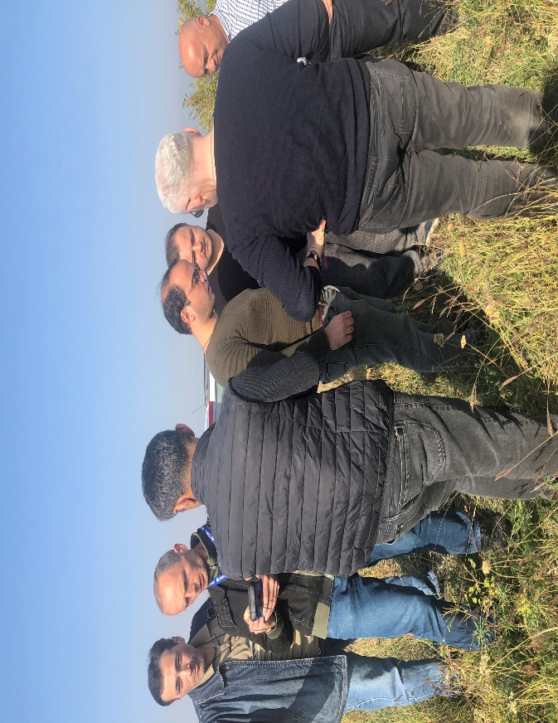
Photo 2: Levan (Revaz) Nemsadze and Plot
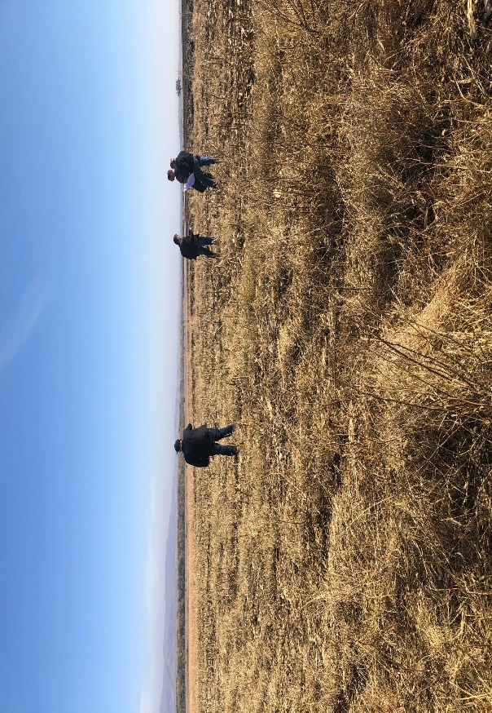

MINUTES of the PP Presentation and Public Discussion on detailed design of tertiary systems (Kvemo Samgori
Scheme area) in the frame of Design Consultation

TITLE of MEETING | Detailed design of on-farm network (Kv.Samgori area)
TIPE of MEETING | Design Consultation (PP Presentation)
DATE | 25 February, 2020
LOCATION | Sagarejo Municipality  12:00 Sagarejo (City Hall’s facility);
OBJECTIVE | PP Presentation on on-farm detailed design (Kv.Samgori area)  Public Discussion on engineering solutions made for the tertiary systems
ATTENDEES | Mayor of Municipality; Representatives of the local City Hall;  Representative of legal body (Sakrebulo);  Representative of the Ministry of Environmental Protection and Agriculture; Representatives of GA Service Centre;  PR group of GA;  PIU engineers (presenters);  WB International and Regional Consultants; WUO Development Support Team;  Members of 3 Water User Councils (from Sagarejo and the villages: Ninotshminda, Giorgitsminda, Tskarostavi, Iormughanlo, Duzagrama):  - 8 Water Users;  - 6 Mayor’s representatives in Admin.Units;  - 3 CA Service Centre’s representatives.  Other Water Users/farmers.

SUBJECT | BRIEF DESCRIPTION | ACTION
12:00 Sagarejo,  City Hall  PP presentation  and Public discussion (Design Consultation) | The registration of the participants took place at the beginning of the meeting.  The WB Support Team Leader welcomed Sagarejo Mayor and the participants and presented the main objective of the meeting.  He presented all parties/attendees and summarized the activities that were done by the Support Team during the past year (cycle of the Awareness seminars for different target groups, formation of 3 Water User Councils and their participation in the design consultation process as well as in the field surveys and inventory works).  Team Leader reiterated that the Support Team will continue provision of the support and assistance to the farmers during the construction works’ stage and in gradual improvement of WM.  The Mayor of Municipality also welcomed the guests and all attendees and underlined the positive aspects of the cooperation of all actors involved in this specific case as well as the Project progress in general.  The detailed design of the tertiary system was presented by PIU engineer I. Mosavlidze.  He provided the participants with the concept of main | The meeting was  summarized by the Municipality Mayor.  He focused on high importance of the renovation of the amelioration systems and improvement of water supply among the farmers.  Mayor expressed his gratitude to all persons involved in the on-going process for their endeavors to jointly achieve the goal – provision of support to farmers in improvement of their harvest and productivity that will result in increasing their profits.

SUBJECT | BRIEF DESCRIPTION | ACTION
engineering solutions and focused on the specific details regarding the types of irrigation systems (opened and closed)

The number of questions were raised by the farmers about the water intake structure in Iori (along the g-33), about the solutions with the g-33, possibilities of usage of modern irrigation system, etc.

Another question with the similar content regarded the g-2 distribution canal’s service area was raised by the water user from this location.

PIU engineer presented the mentioned location on the screen and responded to the question with detailed technical feedback.

At the end of the discussion, the floor was given to the Regional Adviser who technically explained the benefits of designs (including the planned rehabilitation of tertiary infrastructure) serving as the basis to properly conduct the operational activities-Irrigation measures-of whole system in the future.

The photos of the meetings are presented below

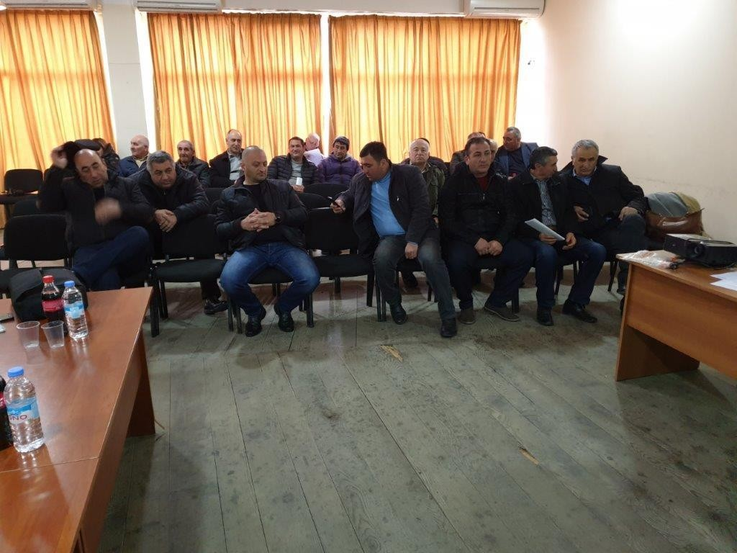
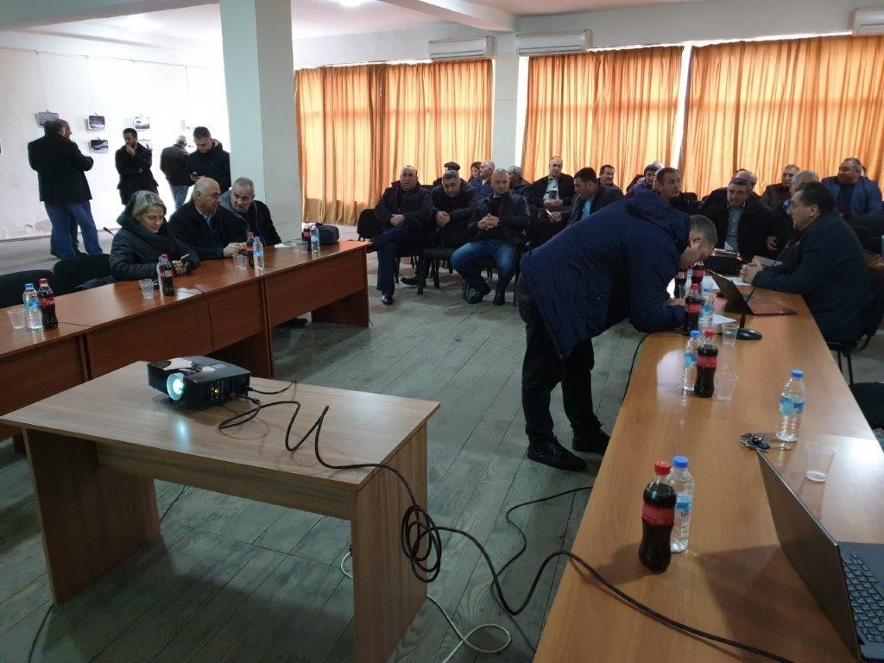

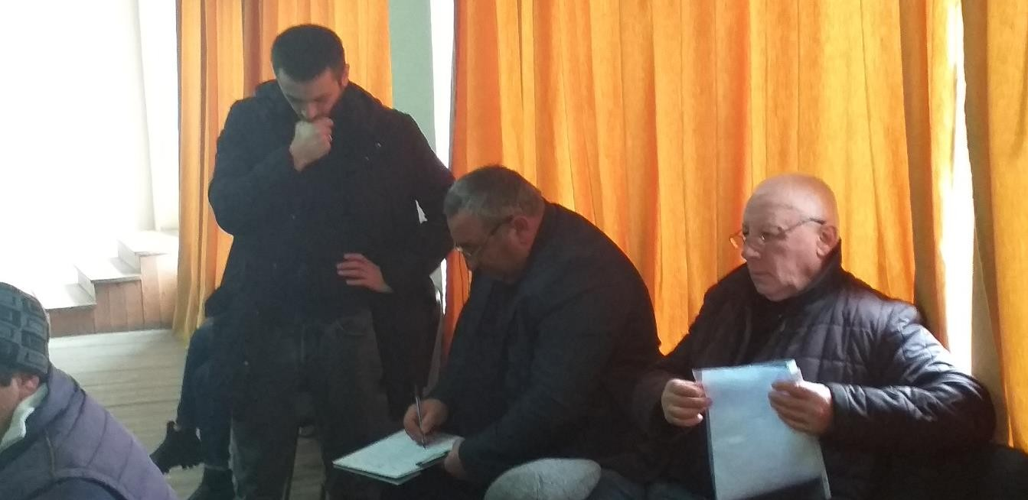
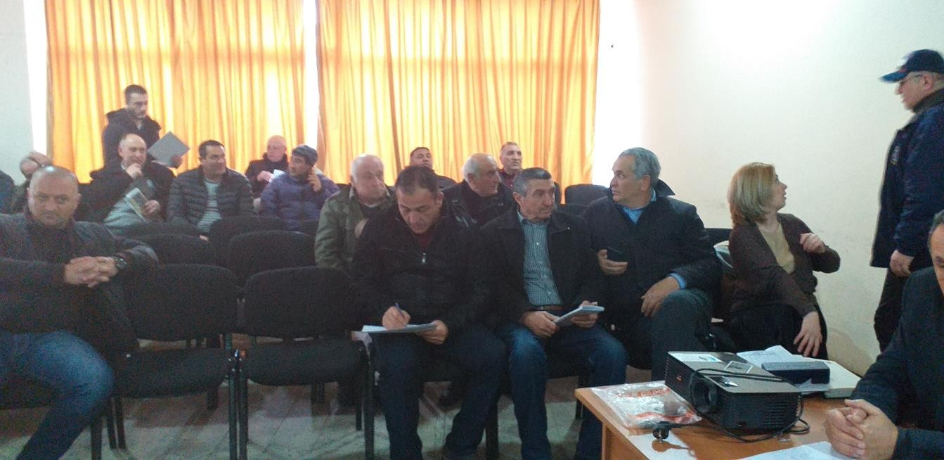
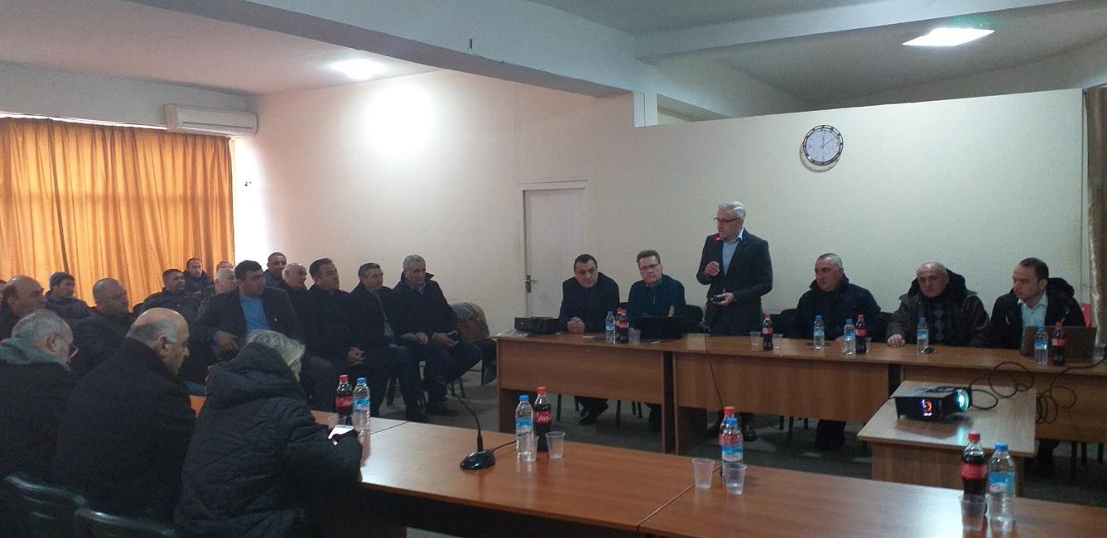

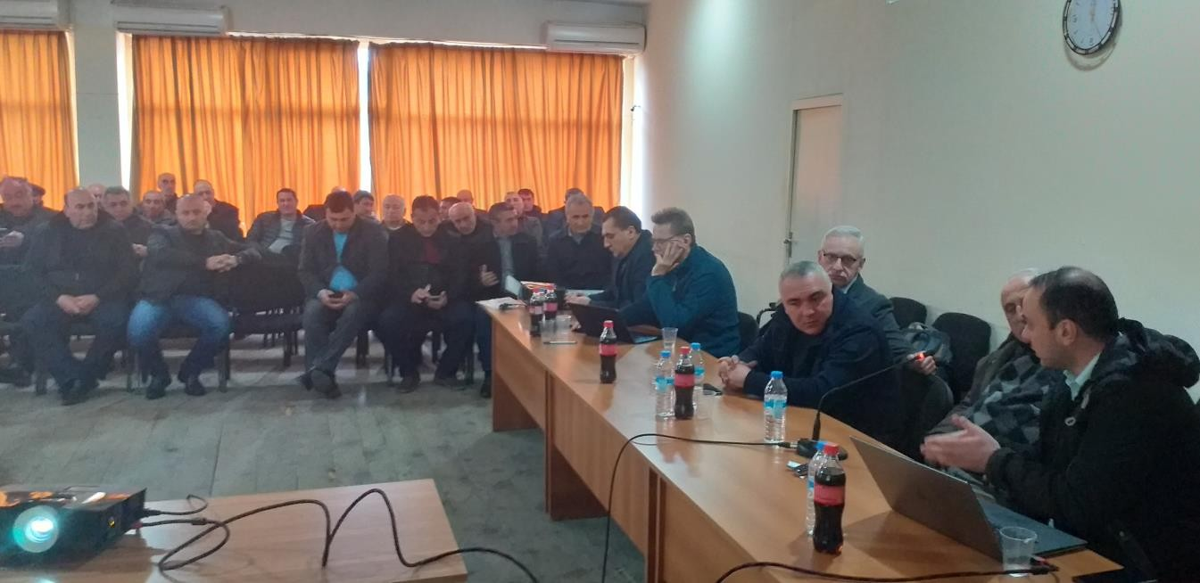

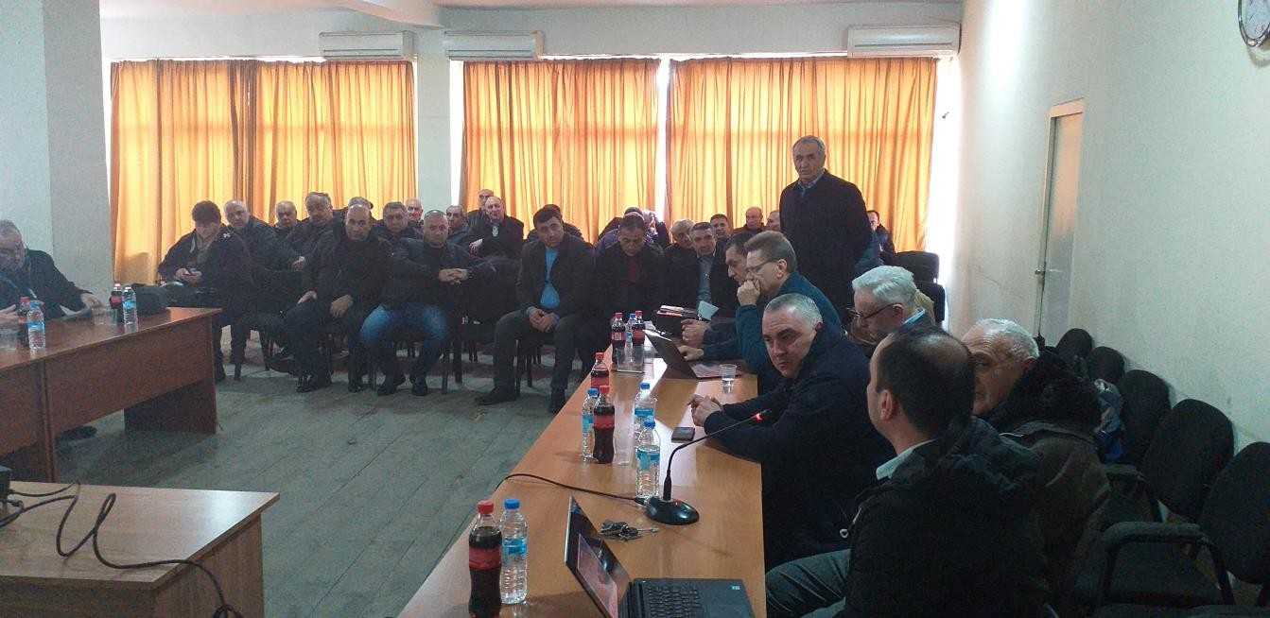

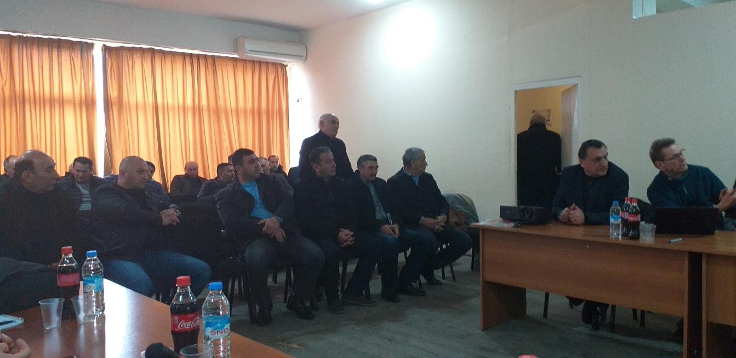

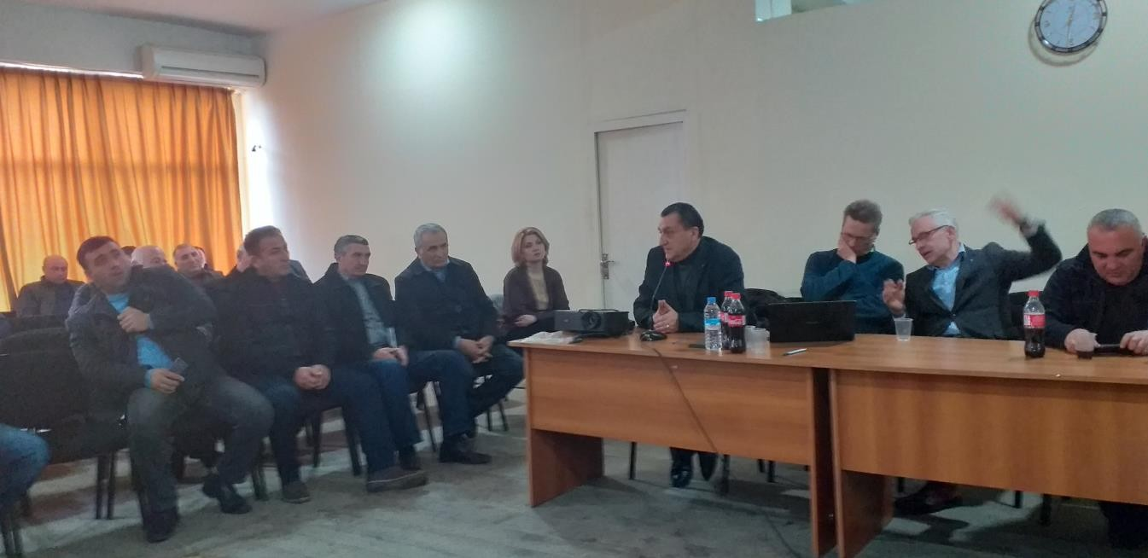
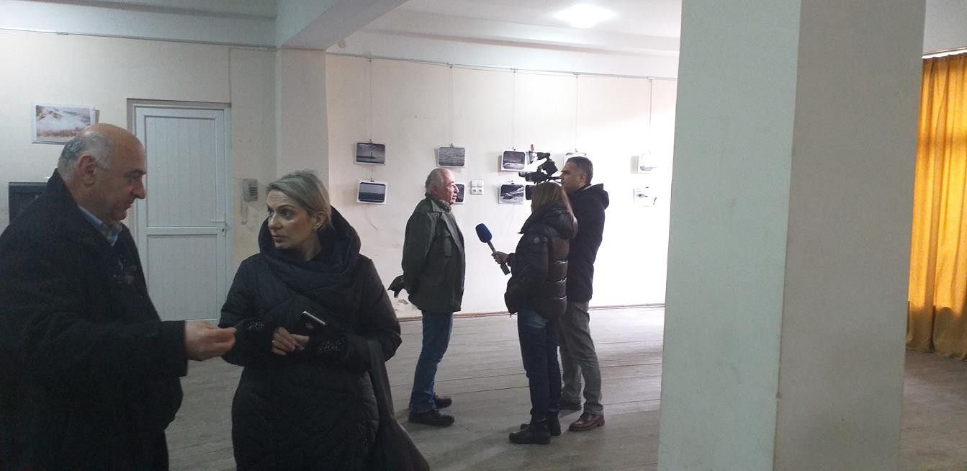
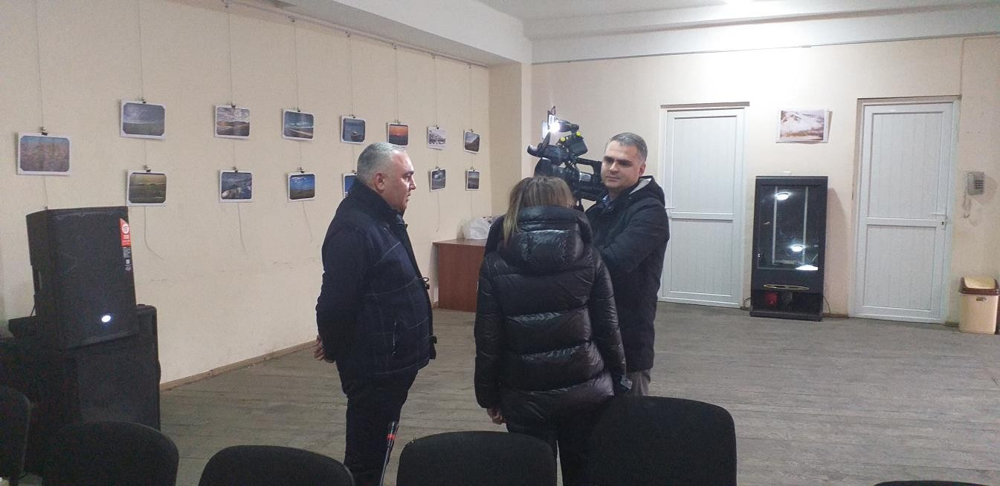

ANNEX 2: GRM Brochure

GEORGIA PROJECT INFORMATION BROCHURE ON GRIEVANCE REDRESS MECHANISM MINISTRY OF ENVIRONMENTAL PROTECTION AND AGRICULTURE OF GEORGIA (MEPA) PROJECT IMPLAMENTATION UNIT

IRRIGATION AND LAND MARKET DEVELOPMENT PROJECT (ILMDP)-P133828
PREPARATION OF DETAILED ENGINEERING DESIGN FOR REHABILITATION AND RECONSTRUCTION OF THE EXISTING SECONDARY AND TERTIARY NETWORKS IN IRRIGATION SYSTEM OF
KVEMO SAMGORI

The World Bank finances the Irrigation and Land Market Development Project (ILMDP) (US$50 million). The project development objective is to improve delivery of irrigation and drainage services in selected areas and to develop improved policies and procedures as a basis for a national program of land registration.

The project consists of the three components: Component 1) Irrigation and Drainage Improvement (US$45.65 million) Component 2) Land Market Development (US$2.25 million) and 3) Project Management (US$2.1 million). Component 1 is implemented by the Ministry of Agriculture through the Project Implementation Unit (PIU). Component 2 is implemented by the Ministry of Justice through the National Agency for Public Registry.

The Irrigation and Drainage Rehabilitation and Modernization Subcomponent will finance rehabilitation and modernization of existing irrigation and drainage schemes selected under the project. Namely, the project will finance rehabilitation of primary, secondary (off-farm), and tertiary (on-farm) canals. Other works, such as head-works, work on dams and on other lands in project area are not envisaged.

The project will only restore existing irrigation canals and does not envisage construction of new schemes. For the first stage of the project, three irrigation schemes have been selected for rehabilitation. Those are - Kvemo Samgori, Tbisi-Kumisi and Zeda Ru irrigation schemes.

This ARAP sets out the measures to be taken in order to mitigate impacts on Project Affected Persons, providing them with adequate compensation, and where necessary, with due assistance for restoring their livelihoods. The RAP is being prepared in consultation with project-affected persons and is subject to further public consultation prior to being implemented.
The Abbreviated Resettlement Action Plan is aligned with the requirements of the WB OP 4.12 and complies with national legislative requirements of Georgia.

To develop the present Abbreviated Resettlement Action Plan, information on final design of civil works provided by Project Implementation Unit.
In case if PAP’s or Stakeholders have any questions, quarries or clarification requirements they can follow the procedure described in this leaflet.
Grievance Redress Mechanism for Abbreviated Resettlement Action Plan
PIU aims to engage with stakeholders on land acquisition and resettlement in a manner that is conciliatory, fair and transparent. Care will always be taken to prevent grievances rather than going through a redress process. Through careful land acquisition design and implementation, by ensuring full participation and consultation with the PAP’s, and by establishing extensive communication and coordination among the various implementation entities, PIU will try to collect feedback and questions from interested parties. A grievance can be defined as an actual or perceived problem that might give grounds for complaint. Nonetheless, PAP’s may find disagreeable a decision, practice or activity related to land acquisition and resettlement.
This section summarizes the grievance redress mechanism for the Project, which will accept grievances, inquiries, and feedback related to resettlement as well as other project-related concerns.
Project Grievance Redress Principles
The following principles underlie the grievance redress mechanism:
    - PAP’s are fully informed of their rights and of the procedures for addressing complaints whether verbally or in writing during consultation, survey, and at the time of compensation;
    - Each grievance is registered, its receipt acknowledged, and tracked until closure;
    - All grievances are processed and responded to within 14 days and the complex grievances up to 30-day time period,
    - Language, literacy and gender are not an impediment for complainants. Presentation of complaints does not incur undue costs to the complainant.
    - At any moment in the project or throughout the GRM process PAPs are free to address their grievances in court.

To ensure full awareness of PAPs on the GRM process, a Project and GRM Brochure is distributed in the project area) and will be made available in the Georgian and Azeri, Russian languages and made in posters and disseminated in the area.

Grievance Resolution Process
The Project resettlement grievance resolution process is summarized in Table below.

Resettlement Grievance Resolution Process
Steps | Grievance Redress Actions
1 | PIU’s ARAP team will maintain a system for logging grievances. PIU SSC will set up registry for complaints.
2 | In the first instance, PAP’s can lodge a grievance and resolution will be attempted at an informal level with the involvement of relevant Project entities (for instance design, cadastral, evaluation) or local representatives within ten 10 days after submission of the grievance. Such grievances will still be recorded in the grievance log.
3 | If still unsettled, the PAP’s can submit the complaint with PIU who has 15 days to decide on the case.
4 | If still unsettled, the PAP’s grievance will move within 15 days to a Grievance Resolution Committee (see the details on the Committee below) which has 15 days to decide on the case.
5 | At any stage of the process the PAP is free to submit the case to the appropriate Georgian court of law.

Grievance Resolution Process
PIU will establish the Land Acquisition Grievance Resolution Committee consisting of the representatives of PIU, MEPA, land valuation / acquisition consultant(s), and concerned PAP’s. Where relevant, the committee will consult the village / community leaders and authorities in order to facilitate the resolution of grievances. PIU representatives on the Committee can include a legal team member, Engineers, Social Safeguard Consultant, Regional Coordinator, Project Manager and the Deputy Project Director. When relevant, the committee consults with community leaders and representations in order to finalize actions. These committee will review and discuss the received grievances internally, take decisions as to how to resolve them, implement a solution, and inform the PAP about compliant result and closure.

Grievance Recording and Logging
The SSC is responsible for recording any grievances which are presented at the local government level and to their staff. They also log activities and their timing until a resolution is achieved. At the local level ensure that the local representative is fully trained in their role related to the GRM. The Land & Social Team is responsible for keeping the complainant informed of decisions and activities undertaken to reach resolution.

PIU Grievance Contact Information
The point of contact regarding the management of grievances by the Project and the local stakeholder engagement activities is PIU Deputy Project Manager:

Description | Rehabilitation and Reconstruction of the Kvemo Samgori irrigation Channel
Client: | Ministry of Environment Protection and Agriculture of Georgia
To: | Giorgi Kalandadze
Address: | 6 Marshal Gelovani Avenue
E-mail: | giorgi.kalandadze@mepa.gov.ge
Website: | www.mepa.gov.ge
Telephone: | 591 518 888

PIU Social Safeguard Consultant – Sophie Berishvili
Description | Rehabilitation and Reconstruction of the Kvemo Samgori irrigation Channel
Client: | Ministry of Environment Protection and Agriculture of Georgia
To | Social Safeguard Consultant – Sophie Berishvili
Address: | 6 Marshal Gelovani Avenue
E-mail: | Sophiko1@hotmail.com
Website: | www.mepa.gov.ge
Telephone: | 599 270 049

Annex #3 – Valuator Report

LLC TIAG AuditEscort შპს თი აი ეი ჯი აუდიტესკორტი
Address: Tbilisi, Universiteti St. N6 ქ. თბილისი, უნივერსიტეტის ქ. N6
E-mail: Info@auditescort.ge E-mail: Info@auditescort.ge
IN:. 205229439 სნ: 205229439
T/Fax:. (+99532) 144 500 T/Fax:. (+99532) 144 500
Site: auditescort.ge Site: auditescort.ge
To Ms. Sophie Berishvili,
In response to the verbal question, we provide an explanation for determining the compensatory value of perennial plants. The cost of plants according to the age group is determined in a unified version. This approach takes into account the average yield of the plant in the project area, but does not consider the level of care of specific plants. Additional detailed study during the evaluation process is advisable when a particular plant (for example in some cases almond) belongs to a particular, unique variety.
In general, experts in the field have acknowledged that some of the plants planted in one plot of land are mostly less fertile, while others are much more fertile. The same is confirmed by the results of the inventory conducted under similar projects. However, our approach, which mediates the peculiarities of planting plants in the plots, the quality, the strength of the seedlings and the ability of productivity/yield, is based on the practice based in Georgia and the best examples of international experience.
The compensation rates prepared by us are based on the above principles of calculation. Our approach is based on the most widely used standard for growing perennials in case of fertile soil and the best climatic conditions, their maximum yield(productivity) rate is set according to age group (seedling (1-4 years), medium yield (5-10 years) and full yield (11-20 years), (21 and above).
I would like to explain that the compensatory value of plants in general depends on their age, the expected yield to be received from each age group, the unit cost per yield, the number of years to be paid, the cost of seedlings and the estimated crop cost, which varies from 15 to 30 percent of fully acceptable amounts depending on the species of the plant. Data on yields and care costs are taken from the relevant literature, scientific papers posted on the Internet, where the specialists of the field take into account the reactions of plants of different species to the climatic conditions of the region.
As for the unit yield, we take into account the average arithmetic of market prices over the last 2 years and this year. We consider this approach to be fair, as a substantially different price may be set for a particular fruit or annual crop in a given year, which does not correspond to the prices established in Georgia in general as a result of demand-supply.
So, for example, a few years ago in the fall, the whole sale price of hazelnuts exceeded 10 GEL, but in the rest years the price of hazelnuts ranged between 4-6 GEL.
Also, in 2018, the non-standard high yields of peaches and plums significantly reduced their price compared to previous years, almost depreciating compared to previous years. However, professional valuers, according to the general standards of evaluation, have always taken into account the market price trend over the last few years, so that the compensation amount is based on the stable price set in recent years.
Here is a specific calculation of the compensatory value of almonds.
Formula:
{ { (B x D) x C } + A } – F
- A - Seedling cost;
- B - Unit yield cost;
- C - The number of years to be paid;
- D - Full productivity per year;
- E - One-year compensation = B x D
- F – Crop costs (15-30%).

The compensatory value of almonds in the age group of 10-30 years:
- A - Seedling cost - 8 GEL
- B - Unit yield cost - 9 GEL
- C - The number of years to be paid - 10 years
- D - Full productivity per year - 7 kg.
- E - One-year compensation = 63 GEL
Full income including the cost of the seedling- 638 GEL
(10 years * 63 GEL (one-year compensation) + 9 GEL (seedling cost))
- F – Crop costs - 160 GEL- {(B x D) x C} + A } x 25%
Compensation amount, including the expenses incurred to generate income - 638 – (25% of 638) = 480 (rounded)
Reference:
Monograph “Georgian Fruit Growing” by Dr. Gogotour Agladze, doctor of the Agricultural Sciences, full member of the Academy of Agricultural Sciences of Georgian and the Russian federation, Laureate of the State Prize of Georgia, Book III (1973y) and book IV (1978y)
- Department of Statistics; www.geostat.ge
- “Fruit Growing” prof: O. Vardzelashvili 2005y
- Horticulture in general fruit growing. Ts. Tatinashvili 1985y.
- https://agrokavkaz.ge
- http://georgianplants.ge/
- General valuation of the International standards 2017 y. Sh. SS-105
- And other
- Mindia Tabaghua

Annex 4 minutes of the ARAP public consultation 08.10.2020

MINUTES of the Public Consultation Meeting of the Abbreviated Resettlement Action Plan for the rehabilitation of tertiary systems in Kvemo Samgori Irrigation Scheme

TITLE of MEETING | Discussion of the Abbreviated Resettlement Action Plan (ARAP) for the Rehabilitation of tertiary system in Kvemo-Samgori Irrigation Scheme
TIPE of MEETING | Public Consultation
DATE of ARAP DISCLOSURE | September 28, 2020
MEETING DATE | October 8, 2020
MEETING VENUE | Sagarejo Municipality, Outdoors at Ninotstminda Municipality Outdoors
OBJECTIVE | Presentation of the Abbreviated Resettlement Action Plan - ARAP for Kvemo-Samgori Irrigation Scheme;  Outdoor Public Consultation meeting on the issues concerning resettlement.  The main objective was to explain what and why resettlement is done, who are the Project Affected People, what are their rights, categories of the land plots, compensation matrix, resettlement program for the project, resettlement policy and principles, legal basis, grievances procedures and how they can approach and claim their rights?
ATTENDEES | Tamar Garsevanidze – The village representative  Population-Villagers (Attachment B: list of the participants)

The meeting was organized by Project Implementation Unit (PIU). The preliminary discussions were made with Sagarejo municipality and its Public Relations Office. The consultation meeting was announced through the web page of the Ministry of Environmental Protection and Agriculture as well as through Sagarejo Municipality and its administrative branches in the villages of Sagarejo municipality. The posters about the meeting were placed in the villages of Ninotsminda, Giorgitsminda, Guzagrama, Iormughalo, Shibliani, Tulari, Lambalo and Khandaura municipality buildings and given to population.
The meeting was conducted in NInotsminda village and population was from this village. The participants were not wearing the face masks, since the meeting was in open space and by the time the meeting was conducted there were no restrictions under the Georgian Law to wear masks in the open areas.
Additionally, between September 27-October 7 2020 PAPs who live in Giorgitsminda, Guzagrama, Iormughalo, Shibliani, Tulari, Lambalo and Khandaura and did not attend the consultation meeting were contacted individually by phone. Social consultant gave them information regarding ARAP, RAP link, GRM brochure and contact information in case if they have any questions. The face to face meetings were conducted with the representatives of the villages between October 11, November 18, 2019. In addition to that during the Consultation meeting of the ESMP June 25, 2020 in Sagarejo Municipality participants of the meeting were provided information on the ARAP as well.
Additional questions raised by PAPs during telephone conversations included how the compensation is calculated? what is ARAP and why it is developed? When the project is implemented?
PIU Consultant explained that compensations are calculated by independent auditor based on the market value; also, consultant explained what is ARAP and why it is developed. Consultant also stated that the project will be implemented in 2020-2021.
The meeting was preceded by registration of participants of the Ninotsminda village. (Attachment B).
S. Berishvili, Environmental and Social Consultant of the PIU, introduced Social and Resettlement aspects of scheme rehabilitation and operation. She talked about the expected social impacts, their mitigation measures and monitoring plan. (See attachment A photos of consultation). Ms. Berishvili also emphasized the importance of the grievances redress mechanism and introduced to public contact persons that can be contacted if and questions arise. She handed out brochures with information of the grievance redress mechanism and presentation of the Abbreviated Resettlement Action Plan - ARAP document to the meeting participants.
The meeting was interactive. A lot of questions were raised by the participants. The main concern was regarding design and they requested more precise explanation how the water will be delivered to secondary land plots. The meeting was attended by the PIU engineer David Karkarashvili, who was in charge of the answering technical and engineering questions.
The resettlement expert provided a detailed explanation of the resettlement policy that is used by the World Bank in the assessment and resettlement process. During the consultation the presentation was distributed among the attendees, which covered in detail the principles of the Abbreviated Resettlement Action Plan, different approaches, compensation measures, etc. The following issues were discussed:
- Categories of the land plots that were affected by the project as presented in the draft ARAP;
- Planning the compensation and resettlement program for the project;
- Resettlement policy and principles;
- Legal basis;
- Valuation Methodology;
- Compensation matrix;
- Grievance Redress Mechanism and contact information.
After the presentation the second part of the consultation was used to answer the questions:
Q&A:
- Q: I was given 1500m² land by the government, however, the land is not registered. How can I register it?

A: After obtaining the ownership/land use documentation, the person can register the land plot at the Public Registry, there is procedure on that, that is relevantly easy to do nowadays, for more details you can apply to public registry or I can give you initial consultation although the land is not under the project area.

- Q: Will there be enough time to harvest the crops this year?

A: Before the laying of the pipe you will have time to harvest the crops.

- Q: Will there be enough water and how shall be get water?

A: the volumes of the water are calculated by designers and it will be enough to water the secondary land plots. There will be hydrants located on the pipes that will give possibility to get water for the certain land plots.

- Q: Will I be compensated if there are no construction works on my land plot?
A: There will be no compensation if the land plot if is not in the resettlement zone.

- Q: How will my compensation be determined?
A: The compensation will be determined based on the assets located on the land plot. Will be assessed by independent evaluator based on the market price of the assets.

- Q: Who developed design and who as in charge of this design?
A: the design was developed by professional group of People comprising of the Turkish and Georgian experts who have very extensive experience. They have calculated all design requirements and based on the outcomes made assumptions and developed project design documentation.

Annex A: Photos of the Public Consultation 08.10.20
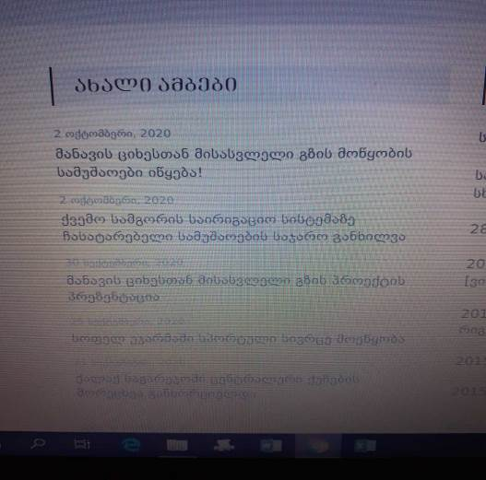
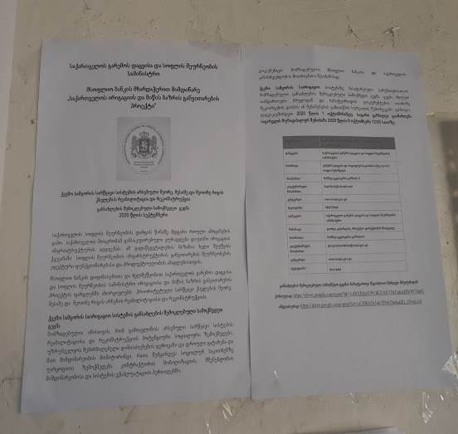
Photo 1 and 2: announcements
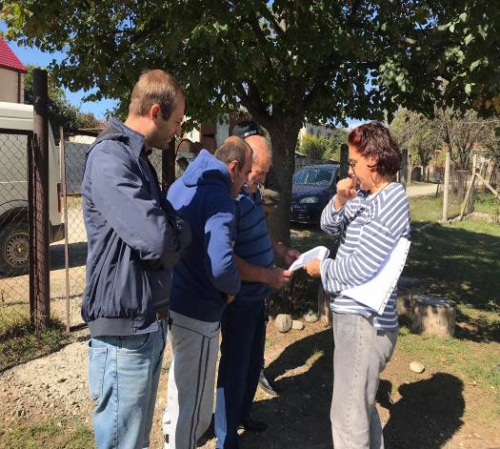
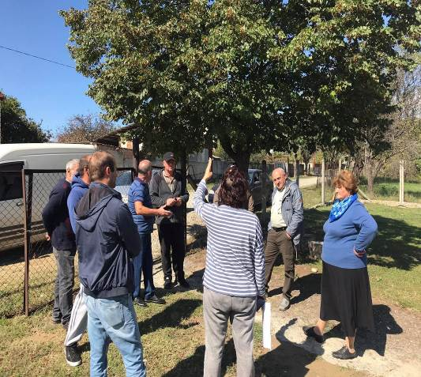
Photo 1 and 2: Outdoor Public Consultation
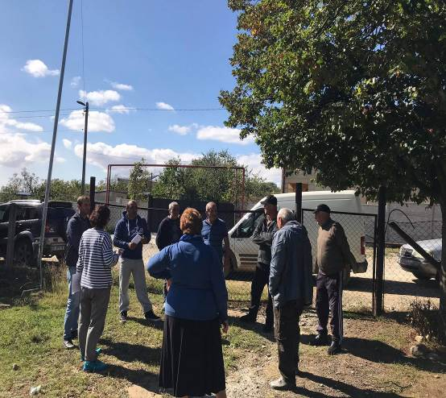
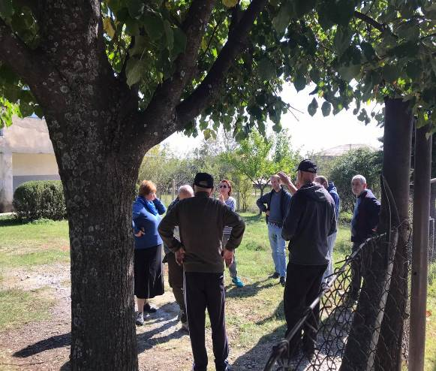
Photo 3 and 4: Outdoor Public Consultation

Annex B: Attendance Sheet of the Public Consultation
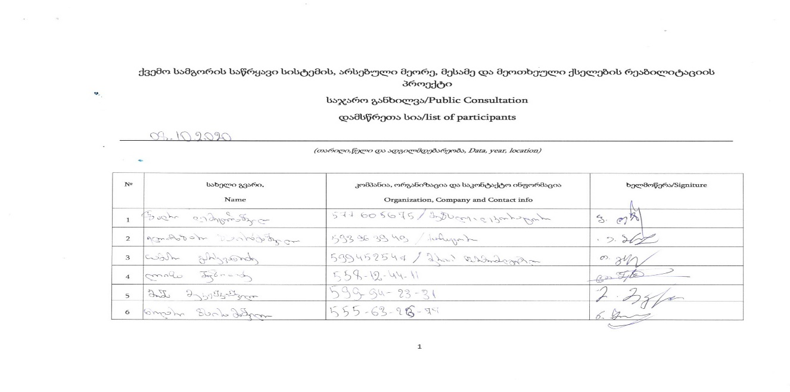

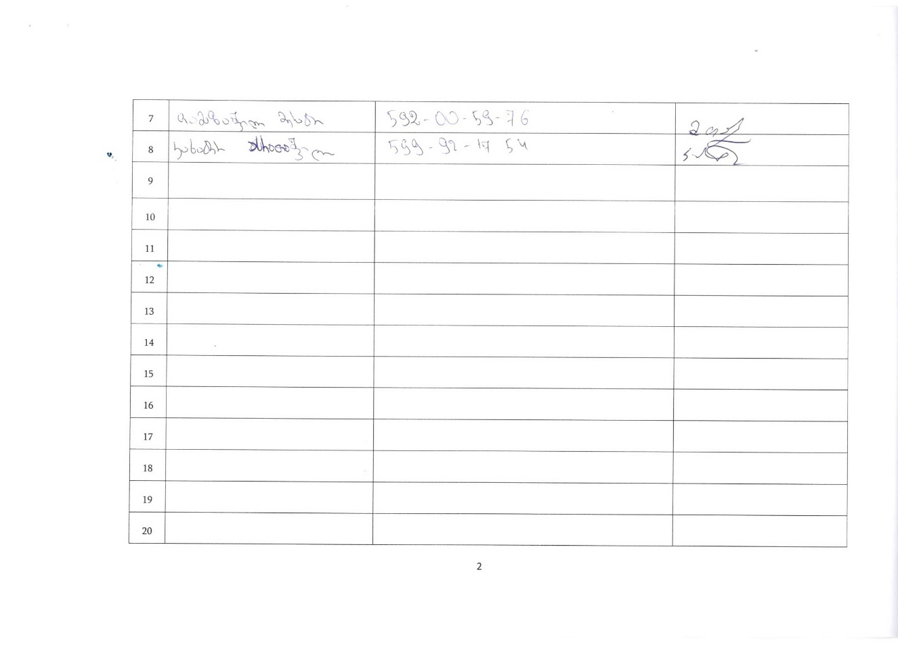

National Statistics Office of Georgia, https://www.geostat.ge/en/modules/categories/316/population-and-demography
This work will be implemented by contractors and all the cost related to the mentioned assistance will be reflected in the Bill of Quantifies of the Construction Company
Given the national state of emergency and social distancing measures in Georgia as a result of COVID-19 pandemic, alternatives to face-to-face meeting will be considered as well. These may include internet-based, phone, and/or media-based provision of information and feedback. The key principles of such consultations will be to ensure that project affected persons and other interested parties have the means to obtain information about the project, provide their views and feedback, and seek response to any feedback, questions, or concerns. All consultations (face to face or alternative ones) will be documented, and records will be attached to this RAP.

